Proximal Supervised Fine-Tuning
接近监督微调

PROXIMAL SUPERVISED FINE-TUNING
接近监督微调

Wenhong Zhu1,2Ruobing Xie3,∗Rui Wang1,2Xingwu Sun3,4Di Wang3Pengfei Liu1,2,∗1Shanghai Jiao Tong University 2Shanghai Innovation Institute 3Tencent
4University of Macau
{zwhong714, wangrui12, pengfei}@sjtu.edu.cn
{xrbsnowing}@163.com
朱文宏1,2谢若冰3,∗王睿1,2孙兴武3,4王迪3刘鹏飞1,2,∗1上海交通大学 2上海创新研究院 3腾讯 4澳门大学 {zwhong714, wangrui12, pengfei}@sjtu.edu.cn {xrbsnowing}@163.com

ABSTRACT
摘要

Supervised fine-tuning (SFT) of foundation models often leads to poor general-ization, where prior capabilities deteriorate after tuning on new tasks or domains. Inspired by trust-region policy optimization (TRPO) and proximal policy opti-mization (PPO) in reinforcement learning (RL), we propose Proximal SFT (PSFT), a fine-tuning objective that incorporates the benefits of trust-region, ef-fectively constraining policy drift during SFT while maintaining competitive tun-ing. By viewing SFT as a special case of policy gradient methods with constant positive advantages, we derive PSFT that stabilizes optimization and leads to generalization, while leaving room for further optimization in subsequent post-training stages. Experiments across mathematical and human-value do-mains show that PSFT matches SFT in-domain, outperforms it in out-of-domain generalization, remains stable under prolonged training without causing entropy collapse, and provides a stronger foundation for the subsequent optimization.1
基础模型的监督微调（SFT）通常会导致泛化能力较差，即在对新任务或领域进行微调后，先前的能力会下降。受强化学习（RL）中信任区域策略优化（TRPO）和近端策略优化（PPO）的启发，我们提出了近端SFT（PSFT），这是一种微调目标，能够结合信任区域的优势，在保持竞争力的同时有效限制SFT过程中的策略漂移。我们将SFT视为具有恒定正优势的策略梯度方法的一个特例，从而推导出PSFT，它能够稳定优化并实现泛化，同时为后续的微调阶段留下进一步优化的空间。在数学和人类价值领域进行的实验表明，PSFT在领域内与SFT表现相当，在领域外泛化方面优于SFT，能够在长时间训练中保持稳定而不会导致熵坍缩，并为后续优化提供了更强的基础。

1 INTRODUCTION
1 引言

Recently, post-training has become a crucial part of the overall training process. In particular, rein-forcement learning (RL) algorithms, such as PPO (Schulman et al., 2017) and GRPO (Shao et al., 2024), have demonstrated significant effectiveness when applied to language models (LMs) focused on reasoning tasks. As RL is scaled over time, foundation models gain the capacity to address com-plex problems through more profound and extended reasoning (OpenAI, 2024; Guo et al., 2025). These reasoning models offer an abundant and valuable latent thoughts (Ruan et al., 2025) across the internet. Numerous community efforts have focused on leveraging this knowledge via super-vised fine-tuning (SFT) (Guha et al., 2025; Li et al., 2025), a distillation approach valued for its efficiency and simplicity compared to RL.
最近，微调已成为整体训练过程中的关键部分。特别是强化学习（RL）算法，如PPO（Schulman等，2017）和GRPO（Shao等，2024），在应用于以推理任务为重点的语言模型（LMs）时表现出显著的效果。随着RL的不断扩展，基础模型获得了通过更深入和广泛的推理来解决复杂问题的能力（OpenAI，2024；Guo等，2025）。这些推理模型在互联网上提供了丰富且有价值的潜在思维（Ruan等，2025）。许多社区努力集中在通过监督微调（SFT）（Guha等，2025；Li等，2025）利用这些知识上，相比RL，这种方法因其高效和简单而受到重视。
However, SFT models are often criticized for poor generalization (Huan et al., 2025). This limita-tion arises because SFT essentially performs behavior cloning, which can result in weak general-ization when the fine-tuning dataset is suboptimal or distributionally misaligned with the pretrain-ing data (Chu et al., 2025), potentially causing large policy updates (Schulman et al., 2015). RL fine-tuning (RFT) provides a promising alternative, as numerous studies have shown that RL better preserves the generalization capabilities that SFT tends to erode (Chu et al., 2025; Huan et al., 2025).
然而，SFT模型经常因泛化能力差而受到批评（Huan等，2025）。这种限制出现的原因是，SFT本质上执行行为克隆，当微调数据集不够理想或与预训练数据分布不匹配时，可能导致泛化能力较弱（Chu等，2025），从而引起较大的策略更新（Schulman等，2015）。强化学习微调（RFT）提供了一种有前景的替代方案，因为大量研究表明，RL更好地保持了SFT往往削弱的泛化能力（Chu等，2025；Huan等，2025）。
Another concern is maintaining the ability to explore. In practice, SFT is often used as a cold start to stabilize RFT training. The gains from RFT may largely come from refining capabilities already acquired during pretraining and SFT (Gandhi et al., 2025). However, excessive reliance on SFT can diminish a model’s capacity for exploration (Xie et al., 2024), as it would cause the entropy collapse (Cui et al., 2025) and thereby constrain exploration during RL training (Yu et al., 2025).
另一个担忧是保持探索能力。实际上，SFT 通常被用作冷启动来稳定 RFT 训练。RFT 的收益可能在很大程度上来自于提升在预训练和 SFT 阶段已经获得的能力（Gandhi 等，2025）。然而，过度依赖 SFT 会削弱模型的探索能力（Xie 等，2024），因为它会导致熵坍缩（Cui 等，2025），从而在强化学习训练过程中限制探索（Yu 等，2025）。
Therefore, the current challenges lie in improving the generalization and exploration keeping of SFT models. To tackle these challenges, this paper proposes an improved fine-tuning strategy Proximal Supervised Fine-Tuning (PSFT) that avoids rote learning and achieves re-liable performance. Specifically, we establish a theoretical connection between SFT and RL, and
因此，当前的挑战在于提高SFT模型的泛化能力和探索保持能力。为了解决这些挑战，本文提出了一种改进的微调策略——邻近监督微调（PSFT），该策略避免了死记硬背，实现了可靠的表现。具体来说，我们建立了SFT与强化学习（RL）之间的理论联系，并

∗Corresponding authors.
通讯作者
1Code is available at https://github.com/zwhong714/PSFT.
代码可在 https://github.com/zwhong714/PSFT 获取。

1

Proximal Supervised Fine-Tuning
接近监督微调

introduce a novel objective based on a clipped surrogate objective that leverages the benefits of trust regions to constrain policy updates.
引入一种基于截断替代目标的新目标，利用信任区域的优势来约束策略更新。
Our experiments demonstrate that, compared to standard SFT, PSFT attains comparable perfor-mance on the target task while preserving the model’s general capabilities. Moreover, PSFT mit-igates entropy collapse during training and yields superior target and generalization performance in subsequent RL stages. We evaluate PSFT on both the mathematics and human value alignment domains, highlighting the broad applicability of PSFT in practice.
我们的实验表明，与标准的SFT相比，PSFT在目标任务上取得了可比拟的性能，同时保留了模型的一般能力。此外，PSFT在训练过程中缓解了熵坍缩问题，并在后续的强化学习阶段中表现出更优的目标性能和泛化性能。我们在数学和人类价值对齐领域评估了PSFT，突显了PSFT在实际应用中的广泛适用性。
Our contributions are as follows:
我们的贡献如下：

• We propose PSFT, an optimization method for SFT that adopts a clipped surrogate ob-jective, akin to PPO, to enforce trust-region-like constraints and thereby prevent excessive policy update. This approach maximally preserves the model’s general capabilities while maintaining comparable performance on the target task.
• 我们提出PSFT，这是一种针对SFT的优化方法，采用类似PPO的截断替代目标函数，以施加类似信任区域的约束，从而防止策略更新过度。这种方法在保持模型通用能力的同时，在目标任务上保持了相当的性能。
• PSFT effectively prevents entropy collapse and overfitting during SFT, thereby enabling subsequent RL stages to achieve more robust and superior results on both target-specific and general tasks.
• PSFT 有效防止了在 SFT 过程中的熵坍缩和过拟合，从而使后续的 RL 阶段在特定任务和通用任务上都能获得更加稳健和出色的结果。
• We extensively validate PSFT across various base models, tasks, and evaluation metrics, demonstrating its potential as a promising alternative to standard SFT.
• 我们在多种基础模型、任务和评估指标上广泛验证了PSFT，展示了其作为标准SFT有前景的替代方案的潜力。

2 PRELIMINARIES AND MOTIVATIONS
2 预备知识与动机

2.1 MARKOV DECISION PROCESS FORMULATION
2.1 马尔可夫决策过程表述

We formulate the problem of language modeling and optimization in the framework of a Markov Decision Process (MDP). An MDP is defined by a tuple (S, A, P), where: S is the state space, representing partial sequences. A is the action space, representing possible next tokens. P(s′| s, a) is the transition probability of moving from state s to s′given action a. In the context of auto-regressive LMs, a query sequence x := (x1, . . . , xm) ∈X initializes the state. A response sequence y := (y1, . . . , yn) ∈Y is generated by sequentially sampling actions (tokens) from the policyπθ. The joint probability of y given x is: πθ(y | x) =Qn t=1πθ(yt | y<t, x), where y<t := {y1, . . . , yt−1} and the state at time t is st = (x, y<t).
我们将语言建模和优化问题建模为马尔可夫决策过程（MDP）框架下的问题。一个MDP由一个元组(S, A, P)定义，其中：S是状态空间，表示部分序列；A是动作空间，表示可能的下一个标记；P(s′|s, a)是从状态s在采取动作a后转移到状态s′的概率。在自回归语言模型的背景下，一个查询序列x := (x1, ..., xm) ∈ X初始化状态。一个响应序列y := (y1, ..., yn) ∈ Y是通过依次从策略πθ中采样动作（标记）生成的。给定x时，y的联合概率为：πθ(y|x) = ∏_{t=1}^n πθ(yt | y<t, x)，其中y<t := {y1, ..., yt−1}，并且在时间t的状态st = (x, y<t)。

2.2 SFT AS THE SPECIAL POLICY UPDATE
2.2 SFT 作为特殊政策更新

Supervised Fine-tuning. The training objective is to minimize the cross-entropy loss between the model’s predicted token distribution and the ground truth tokens. Formally, the loss is defined as:
监督微调。训练目标是使模型预测的标记分布与真实标记之间的交叉熵损失最小化。正式地，损失定义为：
LSFT(θ) = −ˆE(st,a∗t)∼D [log πθ(a∗t| st)] , (1)
LSFT(θ) = −E_{(s_t,a∗_t)∼D} [log π_θ(a∗_t| s_t)] , (1)
where (st, a∗t) pairs are sampled from an offline dataset D.
其中 (st, a∗t) 对是从离线数据集 D 中采样的。

Policy Gradient. In contrast, policy gradient directly samples trajectories from the current policyπθ interacting with the environment. Using the policy gradient theorem, the corresponding loss function can be defined as follows:
h i
LPG(θ) = ˆE(st,at)∼πθlog πθ(at | st) ˆAt , (2)
策略梯度。相比之下，策略梯度直接从当前策略πθ与环境交互中采样轨迹。利用策略梯度定理，相应的损失函数可以定义如下：
h i
LPG(θ) = ˆE(st,at)∼πθlog πθ(at | st) ˆAt , (2)
whereˆAt is the estimated advantage function at step t.
其中 $\hat{A}_t$ 是第 $t$ 步估计的优势函数。
From this perspective, SFT can be seen as a special case of policy gradient where sampling is from a fixed offline dataset D and the advantage is fixed asˆAt = 1 for the ground-truth action, which corresponds to maximizing the likelihood of expert tokens.
从这个角度来看，SFT 可以被视为策略梯度的一个特例，其中采样来自固定的离线数据集 D，优势固定为 ˆAt = 1，对应于最大化专家标记的似然。

2.3 PROXIMAL POLICY OPTIMIZATION
2.3 接近策略优化

Trust Region Policy Optimization. TRPO (Schulman et al., 2015) maximizes a surrogate ob-jective by leveraging trajectories collected under the previous policy πθold, introducing importance sampling to reweight these samples for evaluating the new policy πθ:
信任区域策略优化。TRPO（Schulman 等，2015）通过利用在旧策略 πθold 下收集的轨迹来最大化一个替代目标，引入重要性采样来重新加权这些样本，以评估新策略 πθ：

2

Proximal Supervised Fine-Tuning
接近监督微调

L(θ) =E(st,at)∼πθold CPIˆ πθ (at | st) πθold (at | st) Atˆ=Etˆ h rt(θ)Atˆ i , (3)
L(θ) = E_{(st,at)∼π_θ^{old}} \left[ \log \frac{π_θ (at | st)}{π_θ^{old} (at | st)} \right] \cdot \hat{A}_t = E_{\hat{t}} \left[ \hat{r}_t(θ) \hat{A}_t \right], (3)

where rt(θ) is the importance sampling ratio, and the superscript CPI refers to conservative policy iteration (Kakade & Langford, 2002). By introducing a trust region constraint on the KL diver-gence between πθ and πθold, TRPO ensures that each policy update does not deviate too far from the reference policy.
其中，rt(θ) 是重要性采样比率，上标 CPI 表示保守策略迭代（Kakade & Langford, 2002）。通过在策略 πθ 与 πθold 之间的 KL 散度上引入信任区域约束，TRPO 确保每次策略更新不会偏离参考策略太远。

Proximal Policy Optimization. However, directly maximizing LCPIwith a hard KL constraint, as in TRPO, can be difficult to optimize in practice. To address this, PPO (Schulman et al., 2017) modifies the surrogate objective by penalizing policy changes that move rt(θ) too far from 1. The clipped surrogate objective is:
邻近策略优化。然而，像TRPO那样直接以硬KL约束最大化LCPI，在实践中可能难以优化。为了解决这个问题，PPO（Schulman等，2017）通过惩罚使rt(θ)偏离1太远的策略变化来修改替代目标。裁剪后的替代目标为：

h i
LCLIP(θ) = ˆE(st,at)∼πθold min rt(θ) ˆAt, clip(rt(θ), 1 −ϵ, 1 + ϵ) ˆAt . (4)

This clipping mechanism effectively defines a soft trust region: rt(θ) is restricted to remain within a small neighborhood of 1, which prevents destructive updates. Compared to TRPO, PPO achieves similar stability and efficiency.
这种裁剪机制有效地定义了一个软信任区域：rt(θ) 被限制在 1 的一个小邻域内，从而防止了破坏性更新。与 TRPO 相比，PPO 在稳定性和效率方面达到了类似的效果。

3 PROXIMAL SUPERVISED FINE-TUNING
3 近端监督微调

Proximal Supervised Fine-Tuning aims to improve performance on the target SFT task while pre-serving general capabilities, preventing entropy collapse, and allowing further optimization.
邻近监督微调旨在在保持通用能力、防止熵坍缩的同时提升目标SFT任务的性能，并允许进一步优化。

3.1 FROM PPO TO PSFT
3.1 从PPO到PSFT

We revisit the TRPO and PPO objectives in RL. Both methods rely on importance sampling ratios rt(θ) to reweight returns, while constraining these ratios to prevent the new policy πθ from deviating excessively from the old policy πθold. Translating this idea to the supervised setting, where all actions are assumed to be “correct” (i.e.,ˆAt > 0), we simplify the advantage toˆAt = 1, and define the Proximal SFT loss as:
πθ (at | st)
LPSFT(θ) = E(st,at)∼D min πθold (at | st), clip( πθ (at | st)πθold (at | st), 1 −ϵ, 1 + ϵ) . (5)
我们重新审视强化学习（RL）中的TRPO和PPO目标。这两种方法都依赖于重要性采样比率rt(θ)来重新加权回报，同时约束这些比率，以防止新策略πθ与旧策略πθold发生过度偏离。将这一思想转化为监督学习的设定（即假设所有动作都是“正确的”（即ˆAt > 0）），我们将优势函数简化为ˆAt = 1，并定义了近端SFT损失如下：
πθ (at | st)
LPSFT(θ) = E_{(st,at)∼D} min πθold (at | st), clip( πθ (at | st)/πθold (at | st), 1 −ϵ, 1 + ϵ) . (5)
This objective regularizes supervised learning updates by limiting the ratio between the new and old policy probabilities. We allow the old policy πθold—rather than the fixed initial model—to evolve dynamically. Intuitively, it discourages overconfident changes in token probabilities, thereby pre-serving existing capabilities. When changing to the online setting, this method is equivalent to standard SFT training.
这一目标通过限制新策略概率与旧策略概率之间的比率，对监督学习的更新进行正则化。我们允许旧策略 πθold 动态演化，而不是固定初始模型。直觉上，这会抑制对token概率过于自信的更改，从而保留现有的能力。当转换到在线设置时，该方法等同于标准的SFT训练。

Warm-Up. Note that (st, at) in Eq. 5 is sampled from the offline dataset D. In the initial steps, rt(θ) may yield a biased expectation since πθold is not aligned with the distribution of D. The clipping mechanism constrains policy updates within an acceptable range, which may indirectly reduce the negative impact of this mismatch. A warm-up SFT phase on D can be introduced to better align the initial policy πθold with the offline dataset, further improving the SFT/PSFT in-domain performance.
预热。请注意，式5中的(st, at)是从离线数据集D中采样的。在初始步骤中，由于πθold与D的分布不一致，rt(θ)可能会产生有偏的期望。裁剪机制将策略更新限制在可接受的范围内，这可能会间接减少这种不匹配的负面影响。可以在D上引入一个预热的SFT阶段，以更好地将初始策略πθold与离线数据集对齐，从而进一步提高SFT/PSFT在域内的性能。

3.2 GRADIENT ANALYSIS
3.2 梯度分析

The gradient updated is confined to the trust region to perform fine-tuning, similar to that in PPO. The gradient is as follows:
梯度更新被限制在信任区域内以进行微调，类似于PPO中的做法。梯度如下：

∇θLPSFT(θ) = E(st,at)∼D [rt · Itrust (rt) · ∇θ log πθ (at | st)] ,
∇θLPSFT(θ) = E_{(st,at)∼D} [rt · Itrust (rt) · ∇θ log πθ (at | st)] ,
0 rt > 1 + ϵ, (6) where Itrust (rt) = 1 otherwise.
0 rt > 1 + ϵ, (6) 其中 Itrust(rt) = 1 否则。

3

Proximal Supervised Fine-Tuning
近端监督微调

The gradient analysis shows that if the train dataset distribution deviates significantly from the model distribution, these tokens will have no gradient, thereby avoiding large policy updates and maintain-ing generalization. Typically, the optimal value of ϵ is set to 0.2 or 0.28. A larger ϵ can lead to large gradients, as shown in Equation 6. Further analysis is provided in Section 5.2.
梯度分析表明，如果训练数据集的分布与模型分布有显著差异，这些标记将不会产生梯度，从而避免大的策略更新，保持泛化能力。通常，ε的最佳值设置为0.2或0.28。较大的ε会导致较大的梯度，如公式6所示。进一步的分析见第5.2节。

4 EXPERIMENTS
4 实验

In Section 4.1, we explore the training dynamics of our PSFT with standard SFT, and then evaluate both in-domain and out-of-domain performances of models fine-tuned with each method, focusing primarily on the mathematics domain. In Section 4.2, we attempt to verify the effectiveness of PSFT as the cold start point of RL. In Section 4.3, we further conduct experiments in the alignment domain to assess the universal applicability of our approach.
在第4.1节中，我们探讨了我们的PSFT与标准SFT的训练动态，并评估了使用这两种方法微调模型在领域内和领域外的性能，主要集中在数学领域。在第4.2节中，我们尝试验证PSFT作为强化学习冷启动点的有效性。在第4.3节中，我们进一步在对齐领域开展实验，以评估我们的方法的普遍适用性。

4.1 MAIN EXPERIMENTS ON MATH REASONING IN THE SFT STAGE
4.1 SFT阶段中数学推理的主要实验

Setup. (1) Models and Datasets. We evaluate our method based on Qwen2.5-7B-Instruct (Yang et al., 2025) and Llama3.1-8B-Instruct (Dubey et al., 2024). Our training data focuses on the math domain, aiming to improve general LLM capabilities through math reasoning. We employ the OpenR1-Math-81922long chain-of-thought (CoT) dataset (Face, 2025). (2) Baseline. We consider the SFT method and an SFT variant, denoted as SFTKL, which incorporates KL divergence con-straints into the loss function. The KL regularization coefficient is set to 0.5, while the ϵ parameter in PSFT is fixed at 0.28. More details can be found in Appendix A.1.1.
设置。 (1) 模型和数据集。我们在 Qwen2.5-7B-Instruct (Yang 等人，2025) 和 Llama3.1-8B-Instruct (Dubey 等人，2024) 上评估我们的方法。我们的训练数据聚焦于数学领域，旨在通过数学推理提升通用大语言模型的能力。我们采用 OpenR1-Math-81922long 链式思维（Chain-of-Thought，CoT）数据集（Face，2025）。 (2) 基线。我们考虑了 SFT 方法及其一种变体 SFTKL，该变体将 KL 散度约束纳入损失函数中。KL 正则化系数设置为 0.5，而 PSFT 中的 ϵ 参数固定为 0.28。更多细节请参见附录 A.1.1。

4.1.1 TRAINING DYNAMICS
4.1.1 训练动态

We begin by examining the training dynamics of each method. Specifically, we train each for around 10 epochs and plot the corresponding changes in entropy and performance. In this section, we use AIME-24 avg@32 to measure in-domain performance and GPQA (Rein et al., 2024) avg@8 to assess out-of-domain performance.
我们首先考察每种方法的训练动态。具体来说，我们对每种方法进行大约10个周期的训练，并绘制熵和性能的变化情况。在本节中，我们使用AIME-24 avg@32来衡量领域内性能，并使用GPQA（Rein等，2024）avg@8来评估领域外性能。

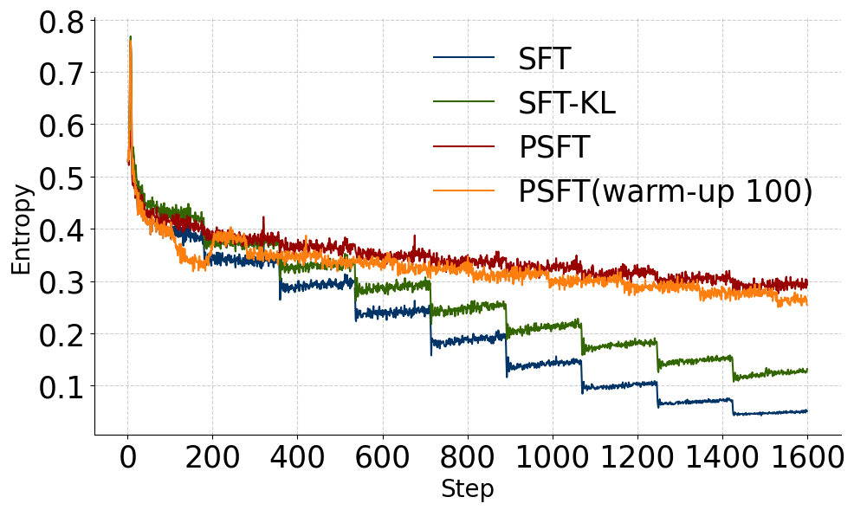
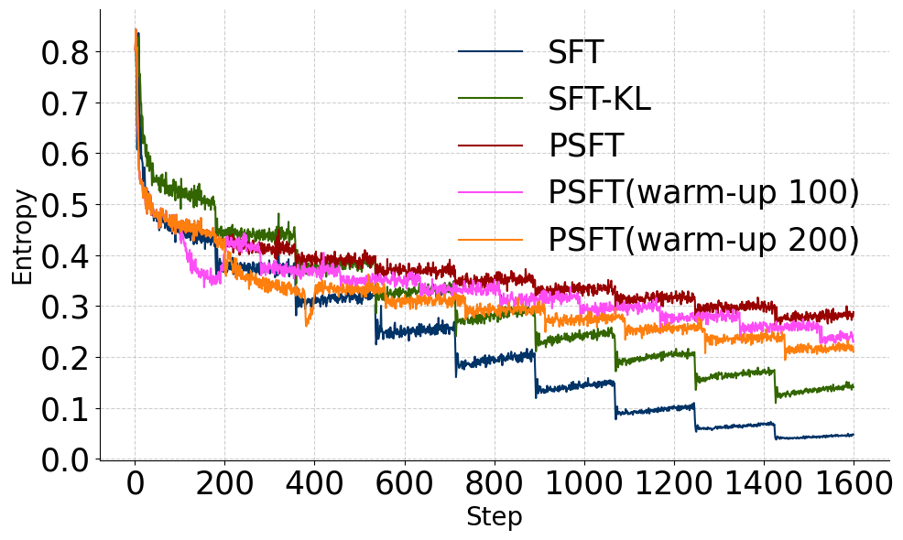

(a) Qwen2.5-7B-Instruct (b) Llama3.1-8B-Instruct
(a) Qwen2.5-7B-Instruct (b) Llama3.1-8B-Instruct

Figure 1: Training dynamics of Entropy. Each 178 steps is one epoch.
图1：熵的训练动态。每178步为一个周期。

Observation 1: PSFT avoids entropy collapse. The entropy evolution is shown in Figure 1. Compared to SFT and SFT-KL, PSFT produces a smoother entropy curve. For SFT and SFT-KL, entropy exhibits a marked decline after each epoch, indicating potential overfitting. This suggests that PSFT is capable of sustaining long-term, token-level fine-grained training without triggering entropy collapse. Notably, PSFT with a warm-up phase demonstrates the same stability, and the number of warm-up rounds plays a critical role in shaping the overall entropy level. Further evidence is provided in Figure 6a.
观察1：PSFT避免了熵坍缩。熵的演化情况如图1所示。与SFT和SFT-KL相比，PSFT产生的熵曲线更加平滑。对于SFT和SFT-KL来说，在每个训练周期后熵都会明显下降，这表明可能存在过拟合现象。这表明PSFT能够在不触发熵坍缩的情况下维持长期的、基于token的精细训练。值得注意的是，带有预热阶段的PSFT表现出相同的稳定性，预热轮次的数量在塑造整体熵水平方面起着关键作用。进一步的证据见图6a。

Analysis 1: PSFT matches or surpasses in-domain performance of standard SFT at a similar entropy level. The in-domain evaluation performance evolution is shown in Figure 2. PSFT
分析1：PSFT在相似熵水平下，其在域内的性能表现与标准SFT相当或更优。域内评估性能的演变如图2所示。PSFT

2The dataset undergoes filtering through Math-Verify to exclude instances with unverifiable answers or responses exceeding 8,192 tokens in length.
数据集通过Math-Verify进行过滤，以排除无法验证答案或响应长度超过8,192个标记的实例。

4

Proximal Supervised Fine-Tuning
接近监督微调

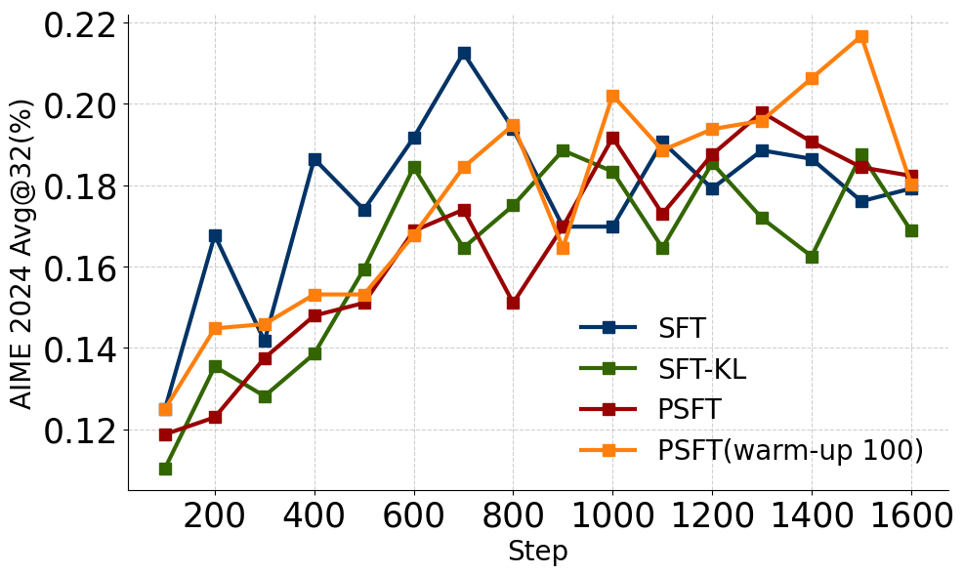
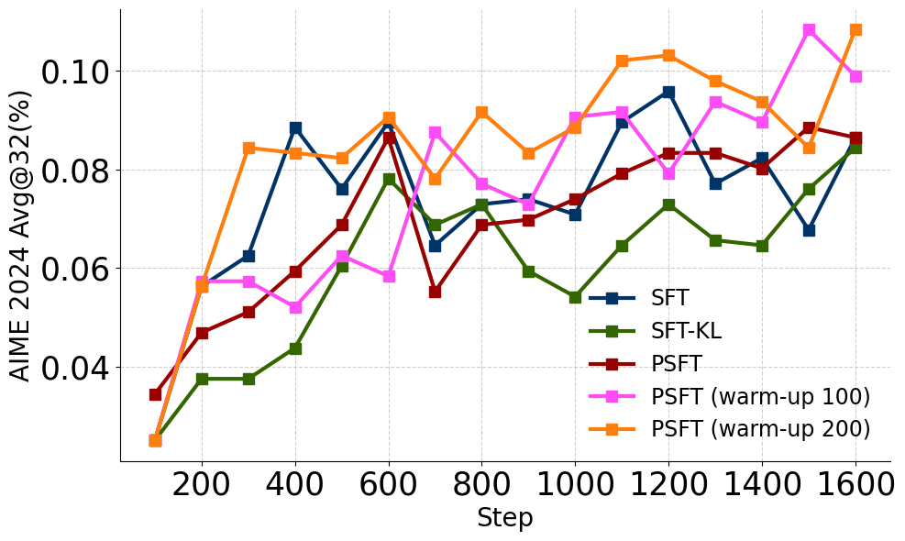

(a) Qwen2.5-7B-Instruct (b) Llama3.1-8B-Instruct Figure 2: Training dynamics of in-domain performance.
(a) Qwen2.5-7B-Instruct (b) Llama3.1-8B-Instruct 图2：领域内性能的训练动态。

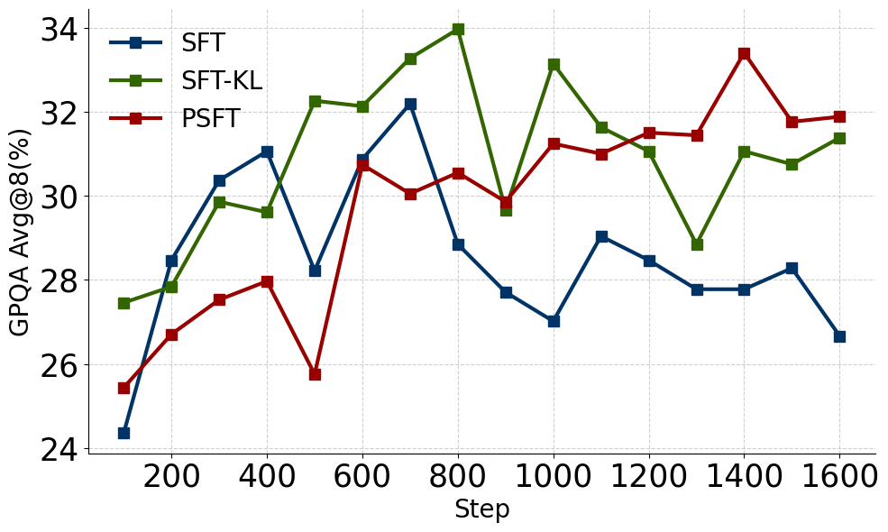
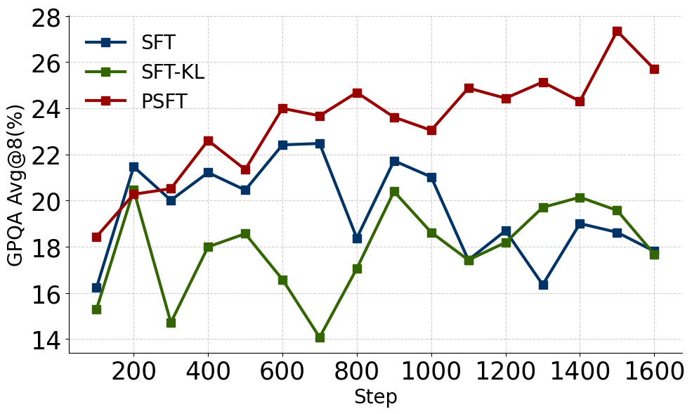

(a) Qwen2.5-7B-Instruct (b) Llama3.1-8B-Instruct
(a) Qwen2.5-7B-Instruct (b) Llama3.1-8B-Instruct

Figure 3: Training dynamics of out-of-domain performance.
图3：领域外性能的训练动态。

achieves comparable performance on targeted math tasks and can even outperform SFT under the same entropy level. For instance, at step 1300, PSFT attains an AIME24 score of nearly 20 with an entropy around 0.3. This entropy level corresponds to that of SFT between epochs 300 and 520, yet PSFT achieves a higher AIME score than SFT within this range. While the KL-based approach intuitively addresses distribution shift, considering both entropy trends and in-domain performance, it remains less effective than PSFT.
在针对数学任务上取得了可比的性能，甚至在相同熵水平下还能优于SFT。例如，在第1300步时，PSFT的AIME24得分接近20，熵值约为0.3。这一熵值对应于SFT在第300到520个周期之间的水平，但在此范围内，PSFT的AIME得分高于SFT。虽然基于KL的方法直观地解决了分布偏移问题，考虑了熵趋势和领域内性能，但其效果仍不如PSFT。

Analysis 2: PSFT with warm-up operation surpasses standard SFT. Figure 2 illustrates the impact of introducing a warm-up phase into PSFT. We observe that the in-domain performance in-creases steadily. Across both models, PSFT with warm-up consistently outperforms vanilla PSFT as well as the standard SFT baselines. Moreover, increasing the number of warm-up steps further en-hances in-domain performance. This offers an effective way to fully exploit high-quality datasets such as s1k (Muennighoff et al., 2025) and LIMO (Ye et al., 2025) while avoiding entropy collapse.
分析2：带有预热阶段的PSFT优于标准的SFT。图2展示了将预热阶段引入PSFT的影响。我们观察到，领域内性能稳步提升。对于两种模型而言，带有预热阶段的PSFT始终优于标准的PSFT以及标准的SFT基线。此外，增加预热步骤的数量进一步提高了领域内性能。这提供了一种有效的方法，可以充分利用高质量数据集，如s1k（Muennighoff等，2025）和LIMO（Ye等，2025），同时避免熵坍缩。

Analysis 3: PSFT can largely maintain the generalization of the model. The evolution of out-of-domain evaluation performance is shown in Figure 3. Increasing the number of training steps leads to a decline in generalization for SFT models. For example, after 700 steps, the SFT method on Qwen2.5-7B-Instruct exhibits a clear decline in performance. While SFT-KL alleviates this degra-dation to a certain degree, PSFT demonstrates substantially better generalization.
分析3：PSFT可以在很大程度上保持模型的泛化能力。图3展示了领域外评估性能的演变情况。增加训练步数会导致SFT模型的泛化能力下降。例如，在700步之后，Qwen2.5-7B-Instruct上的SFT方法表现出明显的性能下降。虽然SFT-KL在一定程度上缓解了这种退化，但PSFT表现出显著更好的泛化能力。
Overall, benefiting from its robust entropy control during training, PSFT avoids large fluctuations in policy updates. As observed in both in-domain and out-of-domain evaluations, PSFT generally maintains an upward performance trend. In contrast, SFT and SFT-KL exhibit pronounced fluctua-tions in out-of-domain performance.
总体而言，得益于其在训练过程中强大的熵控制，PSFT避免了策略更新中的大幅波动。在域内和域外评估中观察到，PSFT通常保持性能的上升趋势。相比之下，SFT和SFT-KL在域外性能上表现出明显的波动。

4.1.2 DETAILED EVALUATIONS
4.1.2 详细评估

Setup. (1) Model setup: For a fair comparison, we select checkpoints based on in-domain per-formance. For instance, on Qwen2.5-7B-Instruct, we use the SFT model trained for 700 steps, the SFT-KL model trained for 900 steps, and the PSFT model trained for 1300 steps. (2) Evaluation
设置。 (1) 模型设置：为了公平比较，我们根据领域内性能选择检查点。例如，在Qwen2.5-7B-Instruct上，我们使用训练了700步的SFT模型、训练了900步的SFT-KL模型以及训练了1300步的PSFT模型。(2) 评估

5

Proximal Supervised Fine-Tuning
接近监督微调

Table 1: Detailed results of in-domain performance. For AIME and AMC, the results are avg.@32. For the rest, the results are avg.@8.
表1：领域内性能的详细结果。对于AIME和AMC，结果为avg.@32。对于其余项目，结果为avg.@8。

Method  方法 | AIME24 | AIME25 | AMC | MATH-500  数学500 | OlympidBench | Minerva  明雅（Minerva） | Avg.  平均值
 |  |  | Qwen2.5-7B-Instruct
Original  原文 | 11.25 | 8.75 | 52.58 | 75.05 | 39.72 | 40.53 | 37.98
SFT | 22.08 | 23.02 | 62.73 | 84.10 | 52.35 | 43.66 | 47.99
SFTKL | 19.27 | 21.56 | 63.20 | 83.55 | 52.70 | 42.19 | 47.08
PSFTwarm-up  PSFT预热 | 22.92 | 23.02 | 62.42 | 84.68 | 52.30 | 43.38 | 48.17
 | 19.38 | 21.98 | 62.34 | 83.35 | 51.50 | 43.33 | 46.98
PSFT
Llama3.1-8B-Instruct
Original  原文 | 3.96 | 0.73 | 24.45 | 48.55 | 17.09 | 25.87 | 20.11
SFT | 10.63 | 16.77 | 47.19 | 72.60 | 41.43 | 32.17 | 36.80
SFTKL | 9.58 | 16.15 | 45.55 | 69.83 | 39.19 | 26.75 | 34.51
PSFTwarm-up  PSFT预热 | 12.08 | 18.75 | 49.45 | 74.15 | 42.07 | 33.64 | 38.36
PSFT | 10.31 | 14.48 | 46.80 | 71.98 | 39.61 | 32.40 | 35.93

Table 2: Detailed results of out-of-domain performance. For GPQA, ARC-C, TruthfulQA, and IFEval, the results are avg.@8. For the rest, the results are pass.@1.
表2：领域外性能的详细结果。对于GPQA、ARC-C、TruthfulQA和IFEval，结果为avg.@8。对于其余项目，结果为pass.@1。

Method  方法 | GPQA | ARC-C | TruthfulQA | MMLU-Pro | SuperGPQA  超级GPQA | HeadQA  头问问答 | IFEvalloose | Avg.  平均值
 |  |  | Qwen2.5-7B-Instruct
Original  原文 | 31.38 | 91.54 | 66.10 | 54.99 | 27.59 | 73.41 | 73.94 | 59.85
SFT | 32.89 | 92.22 | 63.14 | 58.98 | 29.02 | 74.65 | 54.42 | 57.90
SFTKL | 32.95 | 91.86 | 61.31 | 58.35 | 27.69 | 74.07 | 55.44 | 57.38
PSFTwarm-up  PSFT预热 | 33.27 | 92.09 | 66.37 | 59.28 | 28.37 | 75.24 | 55.07 | 58.53
PSFT | 33.21 | 92.29 | 67.16 | 59.18 | 28.10 | 75.82 | 73.03 | 61.26
LLama3.1-8B-Instruct
Original  原文 | 24.62 | 80.96 | 55.14 | 43.70 | 18.16 | 68.20 | 78.10 | 52.70
SFT | 19.38 | 87.73 | 67.08 | 50.29 | 21.95 | 73.52 | 33.45 | 50.49
SFTKL | 18.18 | 87.02 | 67.03 | 47.02 | 19.81 | 71.95 | 34.19 | 49.31
PSFTwarm-up  PSFT预热 | 23.99 | 89.72 | 68.55 | 56.03 | 25.26 | 77.71 | 33.08 | 53.48
PSFT | 26.89 | 89.11 | 68.69 | 56.58 | 25.85 | 77.90 | 69.75 | 59.25

benchmark: (i) In-domain tasks: AIME24, AIME25, AMC, MATH-500 (Hendrycks et al., 2021), OlympidBench (He et al., 2024), and Minerva (Lewkowycz et al., 2022). (ii) Out-of-domain tasks: GPQA (Rein et al., 2024), ARC-C (Clark et al., 2018), TruthfulQA (Lin et al., 2021), MMLU-Pro (Wang et al., 2024), SuperGPQA (Du et al., 2025), HeadQA (Vilares & G´omez-Rodr´ıguez, 2019) and IFEval (Zhou et al., 2023). (3) Inference. The inference length is set to 10,240 tokens (4,096 for IFEval), with a top-p of 0.95 and a temperature of 0.7.
基准：(i) 域内任务：AIME24、AIME25、AMC、MATH-500（Hendrycks 等，2021）、OlympidBench（He 等，2024）和Minerva（Lewkowycz 等，2022）。(ii) 域外任务：GPQA（Rein 等，2024）、ARC-C（Clark 等，2018）、TruthfulQA（Lin 等，2021）、MMLU-Pro（Wang 等，2024）、SuperGPQA（Du 等，2025）、HeadQA（Vilares & G´omez-Rodr´ıguez，2019）和IFEval（Zhou 等，2023）。(3) 推理。推理长度设置为10,240个标记（IFEval为4,096个标记），top-p为0.95，温度为0.7。

Analysis 1. PSFT with warm-up consistently outperforms standard SFT on in-domain tasks. Table 1 presents the performance across various in-domain benchmarks, where all fine-tuned meth-ods achieve notable improvements over the original model. PSFT with a warm-up phase not only stabilizes early training dynamics as illustrated in Figure 2, but also enhances robustness across different evaluation benchmarks.
分析1. 带有预热阶段的PSFT在领域内任务中始终优于标准的SFT。表1展示了各种领域内基准测试的性能，其中所有微调方法都显著优于原始模型。带有预热阶段的PSFT不仅如图2所示稳定了早期的训练动态，还增强了在不同评估基准上的鲁棒性。

Analysis 2: PSFT demonstrates strong generalization. Table 2 shows different performance on out-of-domain benchmarks. Overall, our results are consistent with those reported in Zhou et al. (2025): injecting long CoT data into the model improves its general reasoning ability. However, on IFEval, which evaluates instruction-following capability, SFT, SFT-KL, and PSFT with warm-up significantly degrade the original performance. In contrast, PSFT not only preserves instruc-tion compliance but also substantially enhances the model’s reasoning ability across other domains.
分析2：PSFT表现出强大的泛化能力。表2展示了模型在领域外基准测试中的不同表现。总体而言，我们的结果与周等人（2025）报告的结果一致：将长的CoT数据注入模型中可以提高其一般推理能力。然而，在评估指令遵循能力的IFEval上，SFT、SFT-KL和带预热的PSFT显著降低了原始性能。相反，PSFT不仅保持了指令遵循性，还显著增强了模型在其他领域中的推理能力。
PSFT with a warm-up phase also consistently surpasses standard SFT on out-of-domain tasks.
带有预热阶段的PSFT在领域外任务中也一直超越标准SFT。

6

Proximal Supervised Fine-Tuning
接近监督微调

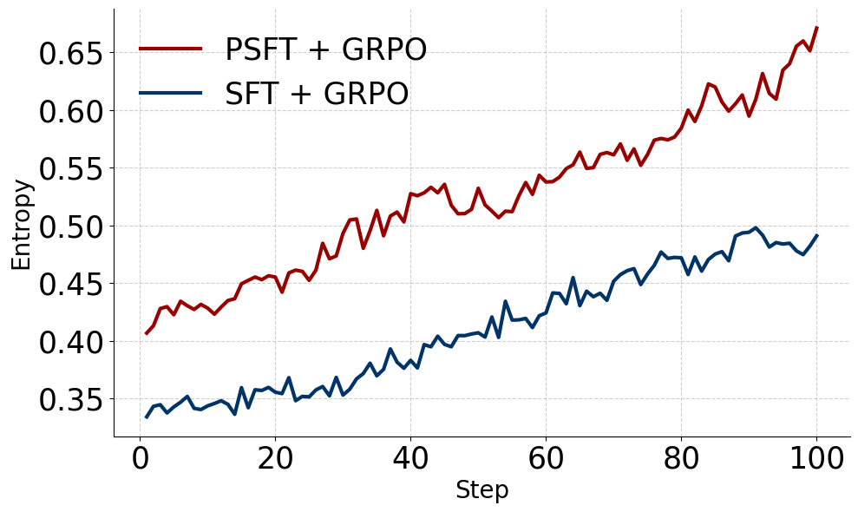
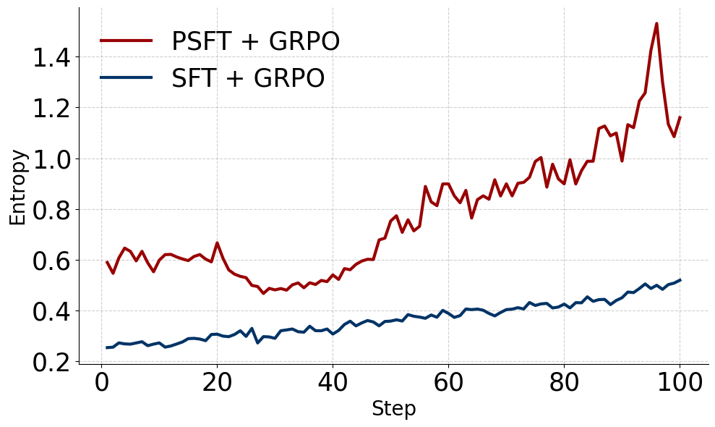

(a) Qwen2.5-7B-Instruct (b) LLama3.1-8B-Instruct Figure 4: Training dynamics of Entropy on RL experiments.
(a) Qwen2.5-7B-Instruct (b) LLama3.1-8B-Instruct 图4：在强化学习实验中熵的训练动态。

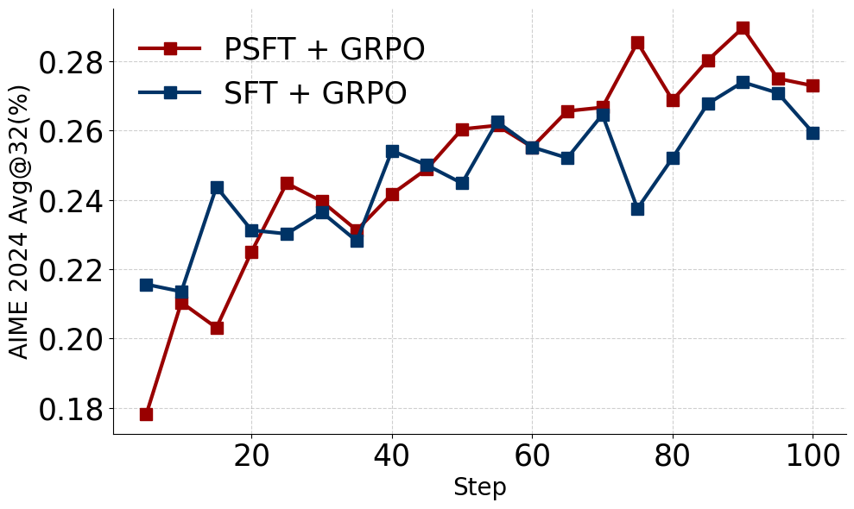
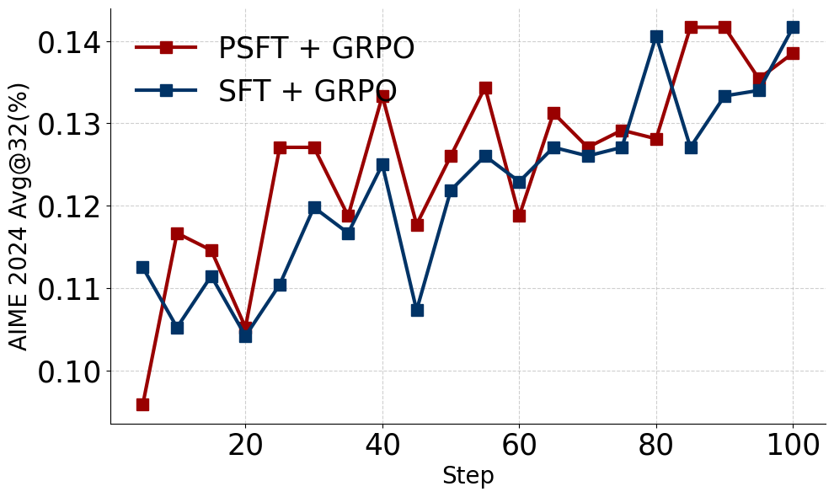

(a) Qwen2.5-7B-Instruct (b) LLama3.1-8B-Instruct
(a) Qwen2.5-7B-Instruct (b) LLama3.1-8B-Instruct

Figure 5: Training dynamics of in-domain performance on RL experiments.
图5：在RL实验中领域内性能的训练动态。

Analysis 3: PSFT demonstrates robustness across models. For example, when evaluating GPQA and TruthfulQA tasks, SFT and SFT-KL exhibit varying behaviors across different mod-els—one sometimes compromises performance while the other may boost it. In contrast, PSFT consistently improves performance, demonstrating a strong advantage over Llama models.
分析3：PSFT在不同模型中表现出鲁棒性。例如，在评估GPQA和TruthfulQA任务时，SFT和SFT-KL在不同模型中表现出不同的行为——有时会牺牲性能，而有时则能提升性能。相比之下，PSFT始终能够提升性能，展现出相对于Llama模型的强大优势。

4.2 EXPLORATION ON THE POTENTIAL OF MODELS IN THE RL STAGE
4.2 在强化学习阶段模型潜力的探索

Practical LLMs often conduct RL after SFT in post-training. The supervised fine-tuned models should function well as an appropriate start point of the following RL stage, avoid both overfitting and underfitting, and better stimulate the potential of RL. In this subsection, we evaluate the power of PSFT in the RL stage.
实用的大型语言模型通常在微调（SFT）之后进行强化学习（RL）。监督微调模型应能作为后续强化学习阶段的良好起点，避免过拟合和欠拟合，并更好地激发强化学习的潜力。在本小节中，我们评估PSFT在强化学习阶段中的效果。

Setup. We adopt all techniques from DAPO (Yu et al., 2025), setting clip-higher to 0.28. The RL training uses the DAPO-MATH-17k dataset (Shao et al., 2024), with detailed training configurations provided in Appendix A.1.2. We further select the checkpoints based on the highest in-domain performance for evaluation.
设置。我们采用DAPO（Yu等，2025）中的所有技术，将clip-higher设置为0.28。强化学习训练使用DAPO-MATH-17k数据集（Shao等，2024），详细的训练配置见附录A.1.2。我们进一步根据最高的领域内性能选择检查点进行评估。

4.2.1 TRAINING DYNAMICS ON RL
4.2.1 在强化学习中的训练动态

Analysis 1: PSFT leaves much room for RL optimization. The RL entropy evolution is shown in Figure 4. As low entropy limits the model’s exploration, it is notable that using PSFT as a cold start results in higher entropy throughout training, with a steeper increase.
分析1：PSFT为RL优化留下了很大空间。RL熵的演变如图4所示。由于低熵会限制模型的探索能力，值得注意的是，使用PSFT作为冷启动可以在整个训练过程中保持更高的熵，且增加速度更快。

Analysis 2: PSFT shows slow start and rapid catch-up in RL. The in-domain performance evolution is presented in Figure 5. Thanks to its high entropy, which promotes exploration, using PSFT as the cold start leads to a relatively steep performance improvement and ultimately surpasses the performance achieved when using SFT as the cold start.
分析2：PSFT在强化学习中表现出缓慢启动和快速追赶的特点。域内性能的演变情况如图5所示。得益于其高熵值，能够促进探索，使用PSFT作为冷启动可以带来相对较快的性能提升，并最终超越使用SFT作为冷启动所达到的性能水平。

7

Proximal Supervised Fine-Tuning
接近监督微调

Table 3: Detailed results of in-domain performance on RL experiments. For AIME and AMC, the results are avg.@32. For the rest, the results are avg.@8.
表3：RL实验中域内性能的详细结果。对于AIME和AMC，结果为avg.@32。对于其他情况，结果为avg.@8。

Method  方法 | AIME24 | AIME25 | AMC | MATH-500 | OlympidBench | Minerva  明雅（Minerva） | Avg.  平均值
Qwen2.5-7B-Instruct
通义千问2.5-7B-Instruct
SFT | 22.08 | 23.02 | 62.73 | 84.10 | 52.35 | 43.66 | 47.99
,→GRPO  →GRPO | 27.40 | 26.15 | 70.86 | 86.60 | 58.09 | 45.27 | 52.40
PSFT | 19.38 | 21.98 | 62.34 | 83.35 | 51.50 | 43.33 | 46.98
,→GRPO  →GRPO | 28.13 | 27.19 | 71.72 | 87.48 | 58.50 | 46.83 | 53.31
Llama3.1-8B-Instruct
SFT | 10.63 | 16.77 | 47.19 | 72.60 | 41.43 | 32.17 | 36.80
,→GRPO  →GRPO | 14.06 | 17.50 | 54.38 | 77.03 | 47.13 | 33.09 | 40.53
PSFT | 10.31 | 14.48 | 46.80 | 71.98 | 39.61 | 32.40 | 35.93
,→GRPO  →GRPO | 14.27 | 18.02 | 55.23 | 77.78 | 47.74 | 37.55 | 41.77

Table 4: Detailed results of out-of-domain performance on RL experiments. For GPQA, ARC-C, TruthfulQA, and IFEval, the results are avg.@8. For the rest, the results are pass.@1.
表4：强化学习实验中域外性能的详细结果。对于GPQA、ARC-C、TruthfulQA和IFEval，结果为avg.@8。对于其余项目，结果为pass.@1。

Method  方法 | GPQA | ARC-C | TruthfulQA | MMLU-Pro | SuperGPQA  超级GPQA | HeadQA  头问问答 | IFEvalloose | Avg.  平均值
 |  |  | Qwen2.5-7B-Instruct
SFT | 32.89 | 92.22 | 63.14 | 58.98 | 29.02 | 74.65 | 54.42 | 57.90
,→GRPO  →GRPO | 39.39 | 92.25 | 61.93 | 62.61 | 33.80 | 75.42 | 53.89 | 59.90
PSFT | 33.21 | 92.29 | 67.16 | 59.18 | 28.10 | 75.82 | 73.03 | 61.26
,→GRPO  →GRPO | 43.43 | 92.42 | 64.84 | 63.65 | 34.51 | 75.89 | 73.73 | 64.06
Llama3.1-8B-Instruct
SFT |  | 19.38 | 87.73 | 67.08 | 50.29 | 21.95 | 73.52 | 33.45 | 50.49
,→GRPO  →GRPO |  | 31.06 | 88.57 | 64.82 | 54.39 | 27.80 | 73.81 | 31.85 | 53.19
PSFT |  | 26.89 | 89.11 | 68.69 | 56.58 | 25.85 | 77.90 | 69.75 | 59.25
,→GRPO  →GRPO |  | 36.23 | 90.92 | 65.24 | 60.92 | 31.30 | 78.12 | 71.02 | 61.96
4.2.2 | DETAILED EVALUATION  详细评估 |  |  |  |  |  | Table 3 presents the results  表3展示了结果
Analysis 3: PSFT achieves better in-domain performance after RL.
分析3：PSFT在强化学习之后实现了更好的领域内性能。
of RL experiments on in-domain benchmarks. Overall, RL improves the performance of all models. A comprehensive evaluation of the in-domain tasks shows that, although PSFT initially lags behind SFT, it holds significant potential that can be further unlocked through RL.
领域内基准的强化学习（RL）实验。总体而言，强化学习提高了所有模型的性能。对领域内任务的全面评估表明，尽管PSFT最初落后于SFT，但其具有巨大的潜力，可以通过强化学习进一步挖掘。

Analysis 4: PSFT outperforms SFT on out-of-domain RL tasks by a large margin. Table 4 presents the results of RL experiments on out-of-domain benchmarks. It is evident that if the orig-inal model exhibits weak capabilities during the cold-start phase, the subsequent RL training is constrained by these limitations. For instance, the IFEval results very clearly reflect this point. This further underscores the necessity of enhancing the current SFT algorithm.
分析4：PSFT在领域外的强化学习任务中表现显著优于SFT。表4展示了在领域外基准上的强化学习实验结果。很明显，如果原始模型在冷启动阶段表现出较弱的能力，后续的强化学习训练就会受到这些限制的影响。例如，IFEval的结果非常清楚地反映了这一点。这进一步强调了改进当前SFT算法的必要性。

4.3 FURTHER EXPERIMENTS ON HUMAN ALIGNMENT
4.3 关于人类对齐的进一步实验

In this section, to demonstrate the universality of PSFT, we extend our experiments to human align-ment datasets, employing different base models and algorithms such as DPO (Rafailov et al., 2023). Our results show that PSFT effectively reduces the alignment tax (i.e., the generalization gap) while still leaving room for further optimization.
在本节中，为了展示PSFT的普适性，我们将实验扩展到人类对齐数据集，采用不同的基础模型和算法，如DPO（Rafailov等，2023）。我们的结果表明，PSFT有效地减少了对齐成本（即泛化差距），同时仍为进一步优化留下了空间。

Setup. We adopt a completely different setup to demonstrate the universality of PSFT further. (1) Model and Dataset. We fine-tune the pre-trained Qwen3-4B-Base (Yang et al., 2025) model with the UltraFeedback dataset (Cui et al., 2023). (2) Training algorithm. We select the chosen region of the dataset and the SFT/PSFT model on it. And for PSFT, we train a double step named PSFTprolong. Then, use the DPO algorithm to enable the model to learn the contrastive reward signal.
设置。我们采用完全不同的设置来进一步展示PSFT的普适性。(1) 模型和数据集。我们使用UltraFeedback数据集（Cui等，2023）对预训练的Qwen3-4B-Base（Yang等，2025）模型进行微调。(2) 训练算法。我们选择数据集中的选定区域以及其上的SFT/PSFT模型。对于PSFT，我们训练一种名为PSFTprolong的双步方法。然后，使用DPO算法使模型学习对比奖励信号。

8

Proximal Supervised Fine-Tuning
近端监督微调

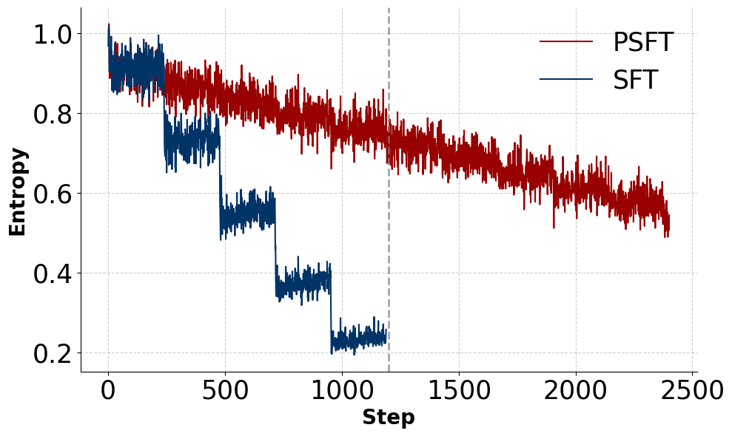
(a) Entropy evolution during SFT/PSFT training.
(a) 熵在SFT/PSFT训练中的演变。
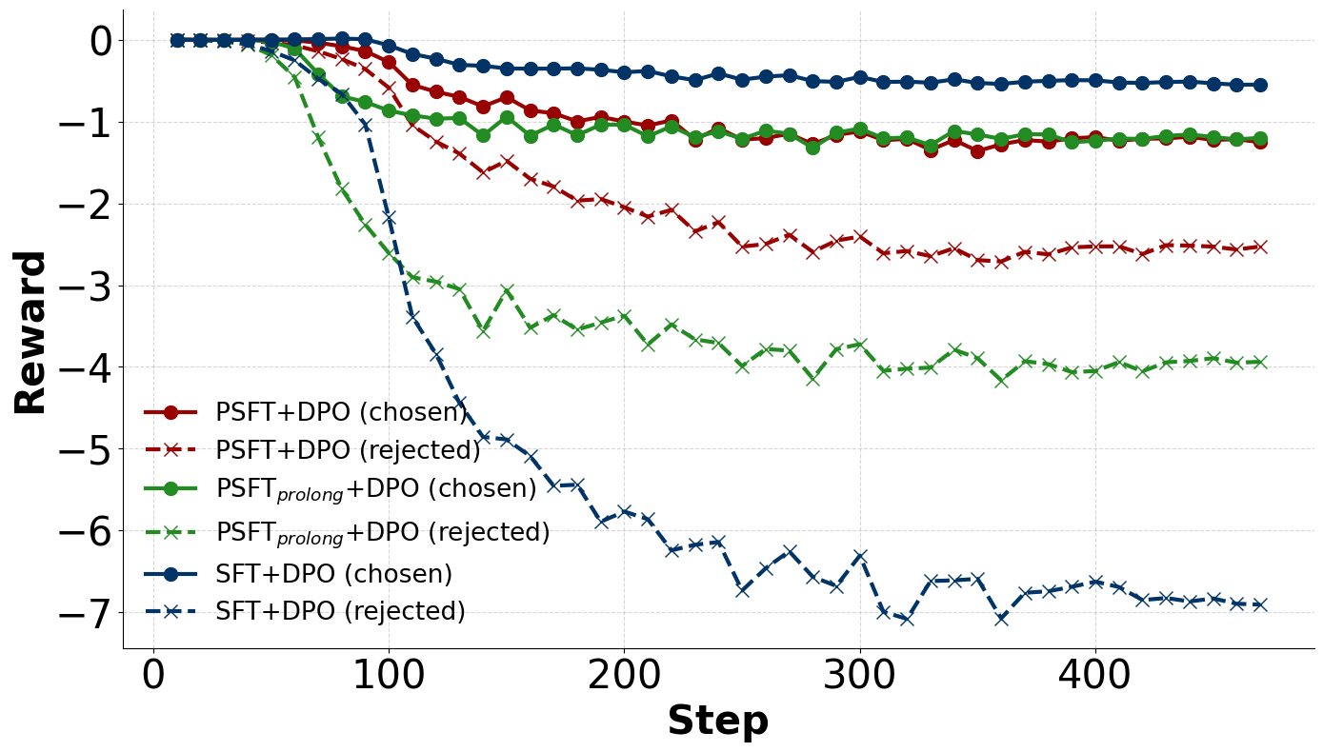
(b) Positive/Negative reward progression during DPO training.
(b) 正/负奖励在DPO训练中的变化趋势。

Figure 6: Training dynamics of SFT/PSFT followed by DPO
图6：SFT/PSFT之后的DPO训练动态

Table 5: Qwen3-4B-Base DPO training on the alignment benchmarks.
表5：Qwen3-4B-Base在对齐基准上的DPO训练。

Method  方法 | AlpacaEval2 |  | Arena-Hard | MT-Bench
 | LC (%)  LC（%） | WR (%)  WR（%） | WR (%) | 1-turn  1圈 | 2-turn  两匝
SFT | 12.24 | 8.52 | 17.90 | 7.64 | 5.71
,→DPO  →DPO | 16.96 | 13.40 | 26.50 | 7.91 | 6.00
PSFTprolong | 11.95 | 8.37 | 17.40 | 7.41 | 5.84
,→DPO  →DPO | 19.26 | 15.17 | 30.20 | 7.63 | 6.74
PSFT | 11.79 | 7.49 | 11.40 | 6.83 | 4.86
,→DPO  →DPO | 23.29 | 20.13 | 36.40 | 8.51 | 6.95

(3) Evaluation. Since short CoT models can not solve the complex problems, we use the ARC, GSM8K (Cobbe et al., 2021), MMLU (Hendrycks et al., 2020), GPQA, and TruthfulQA to evaluate the alignment tax. We evaluate our models on three alignment benchmarks: MT-Bench (Zheng et al., 2024a), AlpacaEval (Dubois et al., 2024), and Arena-Hard (Li et al., 2024a). We use Qwen3-30B-A3-Instruct-2507 (Yang et al., 2025) as the judge model to provide alignment evaluation. We use llm-eval-harness (Gao et al., 2024) to evaluate the alignment tax performance. More experimental setup, see Appendix A.1.3.
（3）评估。由于短程推理模型无法解决复杂问题，我们使用ARC、GSM8K（Cobbe等，2021）、MMLU（Hendrycks等，2020）、GPQA和TruthfulQA来评估对齐税。我们在三个对齐基准测试上评估我们的模型：MT-Bench（Zheng等，2024a）、AlpacaEval（Dubois等，2024）和Arena-Hard（Li等，2024a）。我们使用Qwen3-30B-A3-Instruct-2507（Yang等，2025）作为判断模型，以提供对齐评估。我们使用llm-eval-harness（Gao等，2024）来评估对齐税的性能。更多实验设置，请参见附录A.1.3。

4.3.1 TRAINING DYNAMICS
4.3.1 训练动态

Analysis 1: PSFT still reliably prevents entropy collapse for other domains. As shown in Fig-ure 6a, the entropy loss of SFT still shows a severe sawtooth shape, indicating a potential overfitting phenomenon, while PSFT overcomes this point. Therefore, SFT leads to a severe alignment tax (Figure 7) and restricts further optimization (Table 5).
分析1：PSFT仍然可靠地防止了其他领域中的熵崩溃。如图6a所示，SFT的熵损失仍然表现出严重的锯齿形状，表明可能存在过拟合现象，而PSFT克服了这一点。因此，SFT导致严重的对齐代价（图7），并限制了进一步的优化（表5）。

4.3.2 HUMAN ALIGNMENT PERFORMANCE
4.3.2 人类对齐性能

Analysis2. Table 5 presents the results of DPO experiments on alignment benchmarks. We ob-serve that PSFTprolong achieves a similar effect to SFT training while avoiding entropy collapse, and it performs even better during DPO training. Moreover, using PSFT as the cold-start provides ad-ditional benefits that are further unlocked by DPO. This is consistent as reported by Xiao (2024) that when an SFT model collapses—i.e., becomes overly biased toward certain outputs with near certainty (Figure 6b)—it can subsequently induce preference collapse in the alignment process.
分析2。表5展示了在对齐基准测试中进行DPO实验的结果。我们观察到，PSFTprolong在避免熵坍缩的情况下，实现了与SFT训练相似的效果，并且在DPO训练期间表现得更好。此外，使用PSFT作为冷启动提供了额外的优势，这些优势通过DPO进一步解锁。这与小（2024）报告的一致，即当一个SFT模型发生坍缩——也就是说，过于偏向某些输出（几乎确定）时（图6b）——它随后可能在对齐过程中引发偏好坍缩。

Analysis 3: PSFT training exploits both positive and negative samples well. As shown in Figure 6b, using SFT or PSFT as the cold-start point can influence the subsequent DPO phase. PSFTprolong and PSFT yield similar rewards on positive samples; the main difference is that pro-longed training reduces the occurrence of negative samples. In contrast, SFT training results in positive samples appearing frequently while negative samples are rare, which limits the model’s ability to learn from the reward signal and instead biases it toward the human-selected data.
分析3：PSFT训练很好地利用了正样本和负样本。如图6b所示，以SFT或PSFT作为冷启动点会影响后续的DPO阶段。PSFTprolong和PSFT在正样本上产生相似的奖励；主要区别在于延长训练减少了负样本的出现。相比之下，SFT训练导致正样本频繁出现而负样本很少，这限制了模型从奖励信号中学习的能力，并使其偏向于人类选择的数据。

9

Proximal Supervised Fine-Tuning
接近监督微调

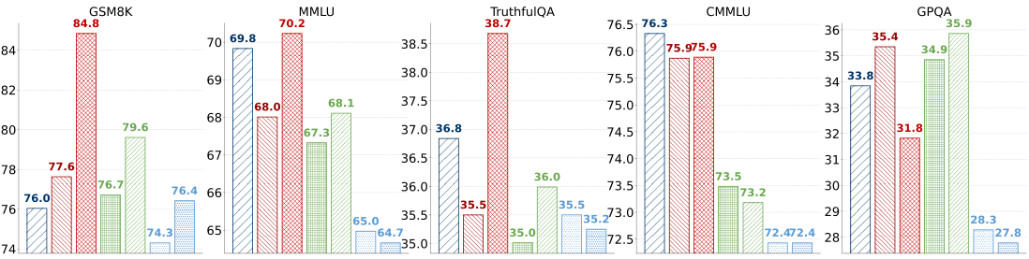

Figure 7: Results of models on alignment tax (out-of-domain tasks).
图7：模型在对齐税（领域外任务）上的结果。

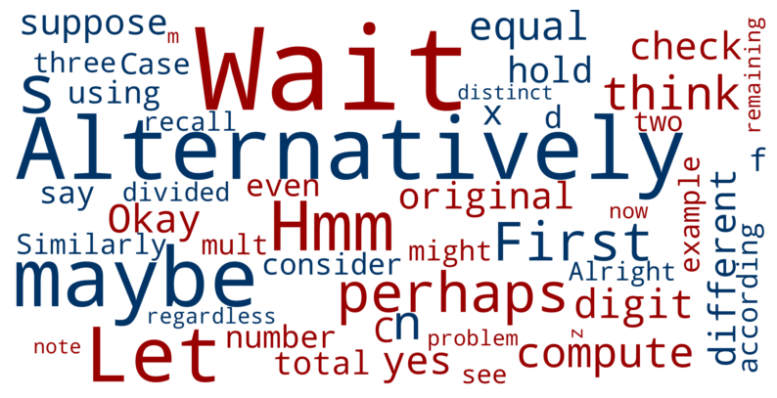
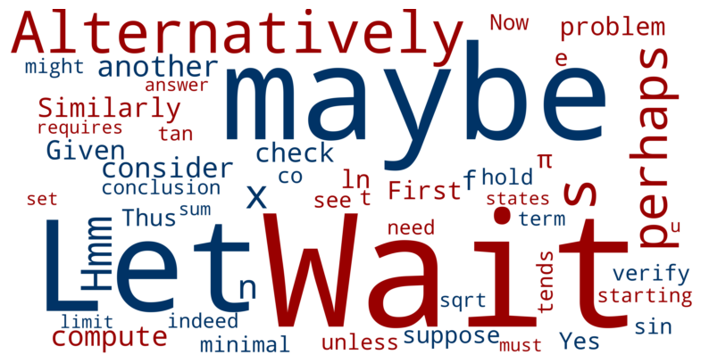

(a) Clipped token cloud in epoch 1. (b) Clipped token cloud in epoch 3.
(a) 第1个周期的截断标记云。 (b) 第3个周期的截断标记云。

Figure 8: Examples and Changes of clipped tokens in PSFT during training.
图8：在训练过程中PSFT中截断标记的示例和变化。

Analysis4. Figure 7 shows the alignment tax results with various tasks (e.g., GSM8K, MMLU, GPQA) as the out-of-domain tasks. It indicates that: (a) PSFT and PSFT+DPO could largely main-tain the general ability during the SFT stage compared to the original SFT. (b) PSFT-Prolong, even being degraded by possible overfitting issues, achieves relatively good results on alignment tax, implying the robustness of PSFT in practical scenarios.
分析4。图7展示了在不同任务（例如GSM8K、MMLU、GPQA）作为域外任务时的对齐税结果。这表明：(a) 与原始SFT相比，PSFT和PSFT+DPO在SFT阶段能够很大程度上保持一般能力。(b) PSFT-Prolong即使可能因过拟合问题而性能下降，但在对齐税上仍取得了相对较好的结果，这表明PSFT在实际场景中的鲁棒性。

5 IN-DEPTH ANALYSES
5 深入分析

5.1 CLIPPED TOKENS IN PSFT
5.1 PSFT中的截断标记

Figure 8 shows the representative clipped tokens during our PSFT’s training process. As we can see, the clipped token mostly concentrates on uncertain words like “wait”, “alternatively”, and similar words that reflect certain “long thinking patterns”, which are also supposed to be learned in the following RL stage. With the training in progress, these token-clip weights are more pronounced, while other tokens become smaller. The “thinking pattern” has been gradually and smoothly learned into models via PSFT, without much disturbance to the general capabilities.
图8展示了我们在PSFT训练过程中出现的代表性裁剪标记。如我们所见，这些被裁剪的标记主要集中在像“wait”（等待）、“alternatively”（或者）等不确定的词语上，这些词语反映了某种“长时间思考模式”，这些模式也应在随后的强化学习阶段中进行学习。随着训练的进行，这些标记裁剪权重变得更加明显，而其他标记的权重则逐渐减小。通过PSFT，这些“思考模式”已被逐步且平滑地融入模型中，而对模型的一般能力影响不大。

5.2 PARAMETER ANALYSIS ON CLIPPED VALUE
5.2 截断值的参数分析

As shown in Figure 9, PSFT without clipping maintains higher entropy but suffers from large, un-stable gradient norms and highly fluctuating downstream results. By introducing the trust-region clipping mechanism, PSFT strikes a better balance: it prevents entropy collapse, stabilizes gradient updates, and achieves steady improvements in performance. Across different clipping thresholds, with medium values of ϵ (e.g., 0.28) showing particularly favorable trade-offs between stability and performance.
如图9所示，未使用截断的PSFT保持了较高的熵，但存在较大的、不稳定的梯度范数和下游结果的剧烈波动。通过引入信任区域截断机制，PSFT取得了更好的平衡：它防止了熵坍缩，稳定了梯度更新，并实现了性能的持续提升。在不同的截断阈值下，采用中等值的ε（例如0.28）在稳定性和性能之间表现出特别有利的权衡。

6 RELATED WORK
6 相关工作

Supervised Fine-tuning. SFT is typically the initial step in the post-training pipeline. Addressing potential issues at the SFT stage can significantly enhance the robustness of the resulting further fine-tuned model. Several studies have noted that the standard cross-entropy (CE) loss may not be
监督微调。SFT通常是训练后的初始步骤。在SFT阶段解决潜在问题可以显著提高最终微调模型的鲁棒性。一些研究指出，标准的交叉熵（CE）损失可能并不

10

Proximal Supervised Fine-Tuning
接近监督微调
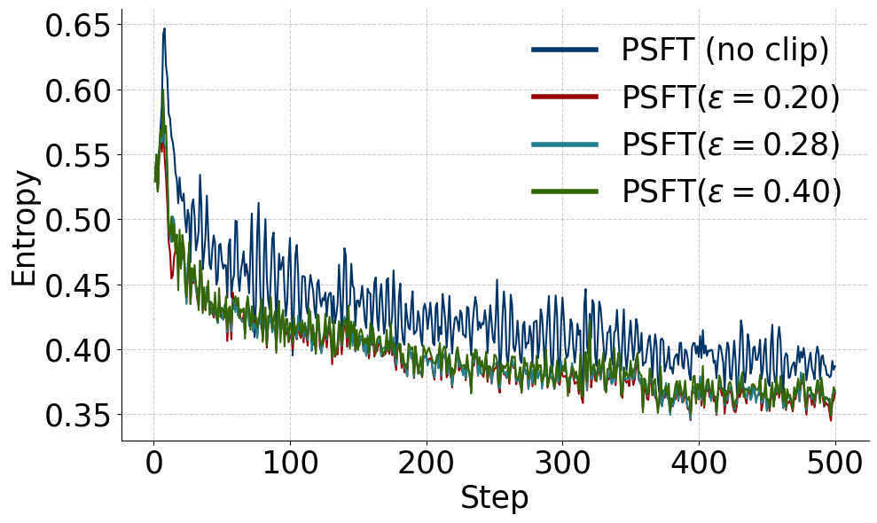 | 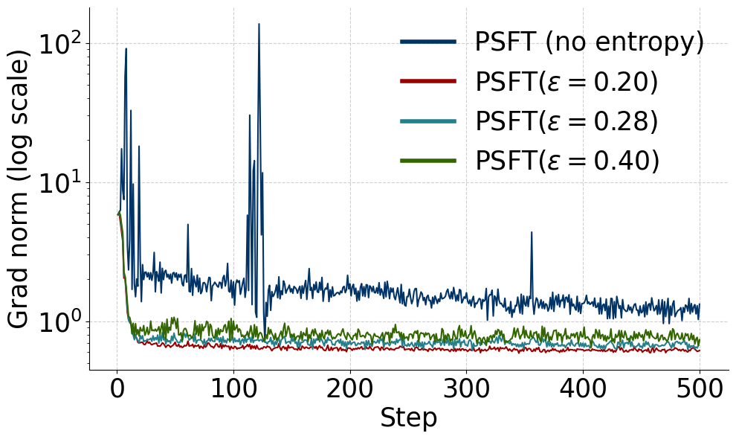 | 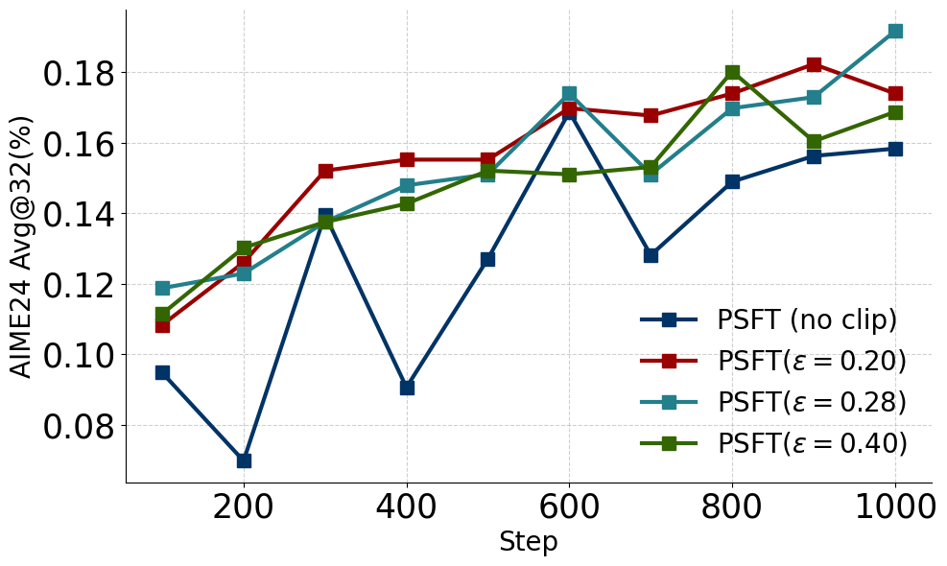
(a) Entropy  (a) 熵 | (b) Gradient Norm  (b) 梯度范数 | (c) Performance  （c）性能
Figure 9: In-domain results of PSFT with different clipped values.
图9：PSFT在不同截断值下的领域内结果。

the most suitable objective for SFT (Li et al., 2024b; Xiao, 2024), arguing that training with CE at this stage tends to encourage the model to memorize the training data rather than acquire more generalizable capabilities. Li et al. (2024b) proposes the GEM, a game-theoretic SFT algorithm with entropy regularization to preserve diversity and mitigate forgetting. The concurrent work is Importance-weighted SFT (iw-SFT) (Qin & Springenberg, 2025) and DFT Wu et al. (2025). The key insight of iw-SFT is to reinterpret standard SFT as optimizing a loose lower bound on the RL objective in a sparse reward setting. While vanilla SFT simply maximizes the likelihood of filtered“successful” trajectories, this lower bound becomes increasingly loose as the model distribution drifts away from the reference policy. iw-SFT addresses this gap by introducing importance re-weighting, which assigns higher weights to more preferred trajectories and thus tightens the bound toward the true RL objective. DFT views SFT as a flawed policy gradient and introduces a simple probability-based reweighting that improves generalization.
SFT（Li 等，2024b；Xiao，2024）中最合适的目标，认为在这个阶段使用CE进行训练往往会促使模型记忆训练数据，而不是获得更普遍适用的能力。Li 等（2024b）提出了GEM，这是一种基于博弈论的SFT算法，通过熵正则化来保持多样性并减少遗忘。同时进行的工作包括基于重要性加权的SFT（iw-SFT）（Qin & Springenberg，2025）和DFT（Wu 等，2025）。iw-SFT 的关键洞察在于重新解释标准的SFT为在稀疏奖励设置下优化RL目标的一个松散下界。虽然普通的SFT只是最大化过滤后的“成功”轨迹的似然，但随着模型分布远离参考策略，这个下界会变得越来越松散。iw-SFT 通过引入重要性重加权来解决这一差距，该方法赋予更受青睐的轨迹更高的权重，从而将下界向真实的RL目标收紧。DFT 将SFT视为有缺陷的策略梯度，并引入了一种简单的基于概率的重加权方法，以提高泛化能力。

Reinforcement Learning. Following SFT, RL is employed to optimize reward signals directly. Policy gradient methods (Sutton et al., 2000) provide the foundation but are prone to instability and high variance. To address this, TRPO (Schulman et al., 2015) introduces a trust-region constraint, limiting each policy update to a small KL-divergence neighborhood to ensure stable improvement. PPO (Schulman et al., 2017) further simplifies this approach with a clipped surrogate objective, striking a balance between stability and efficiency.
强化学习。在SFT之后，RL被用来直接优化奖励信号。策略梯度方法（Sutton等，2000）提供了基础，但容易出现不稳定和高方差的问题。为了解决这个问题，TRPO（Schulman等，2015）引入了一个信任区域约束，将每个策略更新限制在小的KL散度邻域内，以确保稳定的改进。PPO（Schulman等，2017）则通过一个裁剪的代理目标进一步简化了这种方法，在稳定性和效率之间取得了平衡。

7 CONCLUSION
7 结论

Motivated by TRPO and PPO, we propose Proximal Supervised Fine-Tuning (PSFT). PSFT pre-serves a smooth entropy curve while achieving performance comparable to standard SFT at similar entropy levels, and it exhibits strong generalization. Furthermore, using PSFT as a cold-start model facilitates more effective post-training techniques such as RL optimization and DPO. Overall, PSFT presents a promising alternative to traditional SFT.
受TRPO和PPO的启发，我们提出了近端监督微调（PSFT）。PSFT在保持平滑熵曲线的同时，在相似熵水平下实现了与标准SFT相当的性能，并表现出强大的泛化能力。此外，使用PSFT作为冷启动模型有助于更有效地应用后续训练技术，如强化学习优化和DPO。总体而言，PSFT为传统的SFT提供了一个有前景的替代方案。

REFERENCES
参考文献
Tianzhe Chu, Yuexiang Zhai, Jihan Yang, Shengbang Tong, Saining Xie, Dale Schuurmans, Quoc V Le, Sergey Levine, and Yi Ma. Sft memorizes, rl generalizes: A comparative study of foundation model post-training. arXiv preprint arXiv:2501.17161, 2025.
褚天哲、翟越翔、杨纪涵、童盛邦、谢思宁、达莱·舒尔曼斯、Quoc V Le、Sergey Levine 和马毅。SFT 记忆，RL 推广：基础模型微调的比较研究。arXiv 预印本 arXiv:2501.17161, 2025.

Peter Clark, Isaac Cowhey, Oren Etzioni, Tushar Khot, Ashish Sabharwal, Carissa Schoenick, and Oyvind Tafjord. Think you have solved question answering? try arc, the ai2 reasoning challenge. arXiv:1803.05457v1, 2018.
彼得·克拉克、艾萨克·考希、奥伦·埃茨约尼、图沙尔·霍特、阿希什·萨布哈瓦尔、卡丽莎·肖尼克和奥约因·塔福尔德。认为你已经解决了问答问题？尝试ARC，AI2推理挑战。arXiv:1803.05457v1，2018年。

Karl Cobbe, Vineet Kosaraju, Mohammad Bavarian, Mark Chen, Heewoo Jun, Lukasz Kaiser, Matthias Plappert, Jerry Tworek, Jacob Hilton, Reiichiro Nakano, Christopher Hesse, and John Schulman. Training verifiers to solve math word problems. arXiv preprint arXiv:2110.14168, 2021.
卡尔·科布、维尼特·科萨拉朱、莫哈德·巴瓦里安、马克·陈、赫伍·朱、卢卡斯·凯撒、马蒂亚斯·普拉珀特、杰里·特沃雷克、雅各布·希尔顿、中野礼治郎、克里斯托弗·黑塞和约翰·舒尔曼。训练验证器解决数学应用题。arXiv预印本 arXiv:2110.14168, 2021.

Ganqu Cui, Lifan Yuan, Ning Ding, Guanming Yao, Wei Zhu, Yuan Ni, Guotong Xie, Zhiyuan Liu, and Maosong Sun. Ultrafeedback: Boosting language models with high-quality feedback, 2023.
崔甘秋、袁立帆、丁宁、姚冠明、朱伟、倪元、谢国桐、刘智源和孙茂松。Ultrafeedback：通过高质量反馈提升语言模型，2023年。

11

Proximal Supervised Fine-Tuning
接近监督微调

Ganqu Cui, Yuchen Zhang, Jiacheng Chen, Lifan Yuan, Zhi Wang, Yuxin Zuo, Haozhan Li, Yuchen Fan, Huayu Chen, Weize Chen, et al. The entropy mechanism of reinforcement learning for reasoning language models. arXiv preprint arXiv:2505.22617, 2025.
崔淦曲、张宇辰、陈嘉成、袁立帆、王志、左宇欣、李浩瞻、范宇辰、陈华宇、陈伟泽等。强化学习用于推理语言模型的熵机制。arXiv预印本 arXiv:2505.22617, 2025.
Xinrun Du, Yifan Yao, Kaijing Ma, Bingli Wang, Tianyu Zheng, King Zhu, Minghao Liu, Yiming Liang, Xiaolong Jin, Zhenlin Wei, et al. Supergpqa: Scaling llm evaluation across 285 graduate disciplines. arXiv preprint arXiv:2502.14739, 2025.
杜欣润、姚轶凡、马凯景、王炳利、郑天宇、朱 king、刘明浩、梁毅明、金小龙、魏振林等。Supergpqa：在285个研究生学科中扩展大模型评估。arXiv预印本 arXiv:2502.14739, 2025.
Abhimanyu Dubey, Abhinav Jauhri, Abhinav Pandey, Abhishek Kadian, Ahmad Al-Dahle, Aiesha Letman, Akhil Mathur, Alan Schelten, Amy Yang, Angela Fan, et al. The llama 3 herd of models. arXiv e-prints, pp. arXiv–2407, 2024.
阿比曼努·杜比，阿比纳夫·朱尔希，阿比纳夫·潘迪，阿比希克·卡迪安，阿哈德·阿尔-达勒，艾莎·莱特曼，阿基尔·马图尔，艾伦·谢尔滕，艾米·杨，安吉拉·范等。llama 3模型群。arXiv e-prints，第arXiv–2407页，2024年。
Yann Dubois, Bal´azs Galambosi, Percy Liang, and Tatsunori B Hashimoto. Length-controlled al-pacaeval: A simple way to debias automatic evaluators. arXiv preprint arXiv:2404.04475, 2024.
Yann Dubois, Balázs Galambosi, Percy Liang, 和 Tatsunori B. Hashimoto. Length-controlled al-pacaeval: 一种简单的去偏自动评估方法。arXiv预印本 arXiv:2404.04475, 2024.
Hugging Face. Open r1: A fully open reproduction of deepseek-r1, 2025. URL https: //huggingface.co/blog/open-r1.
Hugging Face. 开放 r1：深度搜索-r1 的完全开放复现，2025。URL https: //huggingface.co/blog/open-r1.
Kanishk Gandhi, Ayush Chakravarthy, Anikait Singh, Nathan Lile, and Noah D Goodman. Cogni-tive behaviors that enable self-improving reasoners, or, four habits of highly effective stars. arXiv preprint arXiv:2503.01307, 2025.
Kanishk Gandhi, Ayush Chakravarthy, Anikait Singh, Nathan Lile, Noah D Goodman. 让自我改进推理者能够进行的认知行为，或者说，高效明星的四个习惯。arXiv预印本 arXiv:2503.01307, 2025.
Leo Gao, Jonathan Tow, Baber Abbasi, Stella Biderman, Sid Black, Anthony DiPofi, Charles Fos-ter, Laurence Golding, Jeffrey Hsu, Alain Le Noac’h, Haonan Li, Kyle McDonell, Niklas Muen-nighoff, Chris Ociepa, Jason Phang, Laria Reynolds, Hailey Schoelkopf, Aviya Skowron, Lintang Sutawika, Eric Tang, Anish Thite, Ben Wang, Kevin Wang, and Andy Zou. The language model evaluation harness, 07 2024. URLhttps://zenodo.org/records/12608602.
高乐, 约翰·托, 巴伯·阿巴斯, 斯特拉·比德曼, 西德·布莱克, 安东尼·迪波菲, 查尔斯·福斯特, 劳伦斯·戈丁, 杰弗里·胡, 阿兰·勒诺克, 李涵南, 埃里克·唐, 安妮什·蒂特, 本·王, 凯文·王, 安迪·邹。语言模型评估工具, 2024年7月。网址https://zenodo.org/records/12608602.
Etash Guha, Ryan Marten, Sedrick Keh, Negin Raoof, Georgios Smyrnis, Hritik Bansal, Marianna Nezhurina, Jean Mercat, Trung Vu, Zayne Sprague, et al. Openthoughts: Data recipes for reason-ing models. arXiv preprint arXiv:2506.04178, 2025.
Etash Guha, Ryan Marten, Sedrick Keh, Negin Raoof, Georgios Smyrnis, Hritik Bansal, Marianna Nezhurina, Jean Mercat, Trung Vu, Zayne Sprague, 等人。Openthoughts: 用于推理模型的数据配方。arXiv预印本 arXiv:2506.04178, 2025.
Daya Guo, Dejian Yang, Haowei Zhang, Junxiao Song, Ruoyu Zhang, Runxin Xu, Qihao Zhu, Shirong Ma, Peiyi Wang, Xiao Bi, et al. Deepseek-r1: Incentivizing reasoning capability in llms via reinforcement learning. arXiv preprint arXiv:2501.12948, 2025.
郭 Dayton, 杨德建, 张浩伟, 宋俊霄, 张若雨, 徐润新, 朱启浩, 马世荣, 王培毅, 毕晓, 等. Deepseek-r1: 通过强化学习激励大语言模型的推理能力. arXiv 预印本 arXiv:2501.12948, 2025.
Chaoqun He, Renjie Luo, Yuzhuo Bai, Shengding Hu, Zhen Leng Thai, Junhao Shen, Jinyi Hu, Xu Han, Yujie Huang, Yuxiang Zhang, et al. Olympiadbench: A challenging benchmark for promoting agi with olympiad-level bilingual multimodal scientific problems. arXiv preprint arXiv:2402.14008, 2024.
何朝群，罗仁杰，白宇卓，胡圣丁， leng zhen，沈俊浩，胡金毅，韩旭，黄宇杰，张宇翔等。OlympiadBench：一个用于通过奥林匹克级双语多模态科学问题促进AGI的挑战性基准。arXiv预印本 arXiv:2402.14008, 2024.
Dan Hendrycks, Collin Burns, Steven Basart, Andy Zou, Mantas Mazeika, Dawn Song, and Jacob Steinhardt. Measuring massive multitask language understanding. arXiv preprint arXiv:2009.03300, 2020.
丹·亨德里克斯，柯林·伯恩斯，史蒂文·巴萨特，安迪·祖，曼塔斯·马泽伊卡，唐恩·宋，雅各布·斯坦哈特。衡量大规模多任务语言理解。arXiv预印本arXiv:2009.03300，2020年。
Dan Hendrycks, Collin Burns, Saurav Kadavath, Akul Arora, Steven Basart, Eric Tang, Dawn Song, and Jacob Steinhardt. Measuring mathematical problem solving with the math dataset. arXiv preprint arXiv:2103.03874, 2021.
丹·亨德里克斯，柯林·伯恩斯，索拉夫·卡达瓦特，阿库尔·阿罗拉，史蒂文·巴斯亚特，埃里克·唐，唐恩·宋，雅各布·斯坦哈特。使用math数据集衡量数学问题解决能力。arXiv预印本 arXiv:2103.03874, 2021.
Maggie Huan, Yuetai Li, Tuney Zheng, Xiaoyu Xu, Seungone Kim, Minxin Du, Radha Pooven-dran, Graham Neubig, and Xiang Yue. Does math reasoning improve general llm capabilities?
胡玛吉、李悦台、郑俊益、徐晓宇、金相元、杜敏新、波文德拉·拉达、格雷厄姆·纽比格和杨翔。数学推理能否提升通用大语言模型的能力？
understanding transferability of llm reasoning. arXiv preprint arXiv:2507.00432, 2025.
理解大语言模型推理的可迁移性。arXiv预印本 arXiv:2507.00432, 2025.
Sham Kakade and John Langford. Approximately optimal approximate reinforcement learning. In Proceedings of the nineteenth international conference on machine learning, pp. 267–274, 2002.
Sham Kakade 和 John Langford. 近似最优的近似强化学习. 在第十九届国际机器学习会议论文集, 第267-274页, 2002年.
Aitor Lewkowycz, Anders Andreassen, David Dohan, Ethan Dyer, Henryk Michalewski, Vinay Ra-masesh, Ambrose Slone, Cem Anil, Imanol Schlag, Theo Gutman-Solo, et al. Solving quantitative reasoning problems with language models. Advances in neural information processing systems, 35:3843–3857, 2022.
Aitor Lewkowycz, Anders Andreassen, David Dohan, Ethan Dyer, Henryk Michalewski, Vinay Ra-masesh, Ambrose Slone, Cem Anil, Imanol Schlag, Theo Gutman-Solo 等人。使用语言模型解决定量推理问题。《神经信息处理系统进展》，35:3843–3857，2022年。
Tianle Li, Wei-Lin Chiang, Evan Frick, Lisa Dunlap, Tianhao Wu, Banghua Zhu, Joseph E Gon-zalez, and Ion Stoica. From crowdsourced data to high-quality benchmarks: Arena-hard and benchbuilder pipeline. arXiv preprint arXiv:2406.11939, 2024a.
李天乐、张伟林、埃文·弗里克、莉莎·邓拉普、吴天浩、朱邦华、约瑟夫·E·冈萨雷斯和伊翁·斯托伊卡。从众包数据到高质量基准：Arena-hard和benchbuilder流水线。arXiv预印本 arXiv:2406.11939, 2024a。

12

Proximal Supervised Fine-Tuning
近端监督微调

Yang Li, Youssef Emad, Karthik Padthe, Jack Lanchantin, Weizhe Yuan, Thao Nguyen, Jason We-ston, Shang-Wen Li, Dong Wang, Ilia Kulikov, et al. Naturalthoughts: Selecting and distilling reasoning traces for general reasoning tasks. arXiv preprint arXiv:2507.01921, 2025.
杨莉，优素福·埃马德，卡里克·帕德特，杰克·兰尚汀，韦智元，阮桃，杰森·韦斯顿，梁文光，王东，伊利亚·库利科夫等。Natural Thoughts: 为通用推理任务选择和提炼推理轨迹。arXiv预印本 arXiv:2507.01921, 2025.
Ziniu Li, Congliang Chen, Tian Xu, Zeyu Qin, Jiancong Xiao, Zhi-Quan Luo, and Ruoyu Sun. Preserving diversity in supervised fine-tuning of large language models. arXiv preprint arXiv:2408.16673, 2024b.
李锦秋，陈聪良，徐天，秦泽宇，肖建聪，罗志强，孙若雨。在监督微调大语言模型中保持多样性。arXiv预印本 arXiv:2408.16673，2024b。
Stephanie Lin, Jacob Hilton, and Owain Evans. Truthfulqa: Measuring how models mimic human falsehoods. arXiv preprint arXiv:2109.07958, 2021.
林 Stephanie、霍尔顿 Jacob 和埃文斯 Owain。Truthfulqa：测量模型如何模仿人类的虚假陈述。arXiv预印本 arXiv:2109.07958，2021年。
Niklas Muennighoff, Zitong Yang, Weijia Shi, Xiang Lisa Li, Li Fei-Fei, Hannaneh Hajishirzi, Luke Zettlemoyer, Percy Liang, Emmanuel Cand`es, and Tatsunori Hashimoto. s1: Simple test-time scaling. arXiv preprint arXiv:2501.19393, 2025.
Niklas Muennighoff, Zitong Yang, Weijia Shi, Xiang Lisa Li, Li Fei-Fei, Hannaneh Hajishirzi, Luke Zettlemoyer, Percy Liang, Emmanuel Candès, and Tatsunori Hashimoto. s1: 简单的测试时间缩放。arXiv预印本 arXiv:2501.19393, 2025.
OpenAI. Learning to reason with llms, 2024. URL https://openai.com/index/ learning-to-reason-with-llms/.
OpenAI. 学会用大语言模型进行推理，2024年。网址 https://openai.com/index/ 基于大语言模型的学习与推理.
Chongli Qin and Jost Tobias Springenberg. Supervised fine tuning on curated data is reinforcement learning (and can be improved). arXiv preprint arXiv:2507.12856, 2025.
秦崇礼和乔斯特·托比亚斯·斯普林伯格。在整理数据上进行监督微调是强化学习（并且可以改进）。arXiv预印本 arXiv:2507.12856, 2025.
Rafael Rafailov, Archit Sharma, Eric Mitchell, Christopher D Manning, Stefano Ermon, and Chelsea Finn. Direct preference optimization: Your language model is secretly a reward model. Advances in neural information processing systems, 36:53728–53741, 2023.
拉斐尔·拉法伊洛夫，阿奇特·沙玛，埃里克·米切尔，克里斯托弗·D·曼宁，斯蒂法诺·埃尔蒙，以及切尔西·芬。直接偏好优化：你的语言模型实际上是一个奖励模型。《神经信息处理系统进展》，36:53728–53741, 2023。
David Rein, Betty Li Hou, Asa Cooper Stickland, Jackson Petty, Richard Yuanzhe Pang, Julien Di-rani, Julian Michael, and Samuel R Bowman. Gpqa: A graduate-level google-proof q&a bench-mark. In First Conference on Language Modeling, 2024.
大卫·雷因，贝蒂·李·侯，阿萨·库珀·斯蒂克兰德，杰克逊·佩蒂，理查德·袁哲·庞，朱利安·迪拉尼，朱利安·迈克尔，以及萨缪尔·R·鲍曼。Gpqa：一个研究生级别的谷歌防作弊问答基准。在2024年首届语言建模会议中。
Yangjun Ruan, Neil Band, Chris J Maddison, and Tatsunori Hashimoto. Reasoning to learn from latent thoughts. arXiv preprint arXiv:2503.18866, 2025.
阮杨俊、Neil Band、Chris J Maddison 和 Tatsunori Hashimoto。通过潜在思维进行推理学习。arXiv 预印本 arXiv:2503.18866, 2025.
John Schulman, Sergey Levine, Pieter Abbeel, Michael Jordan, and Philipp Moritz. Trust region policy optimization. In International conference on machine learning, pp. 1889–1897. PMLR, 2015.
约翰·舒尔曼、塞吉埃·利维夫、皮埃尔·阿贝尔、迈克尔·乔丹和菲利普·莫里茨。信任区域策略优化。在国际机器学习会议上，第1889–1897页。PMLR，2015年。
John Schulman, Filip Wolski, Prafulla Dhariwal, Alec Radford, and Oleg Klimov. Proximal policy optimization algorithms. arXiv preprint arXiv:1707.06347, 2017.
约翰·舒尔曼，菲利普·沃斯基，普拉富拉·达里瓦尔，艾利克斯·拉德福德，以及奥列格·克利莫夫。邻近策略优化算法。arXiv预印本 arXiv:1707.06347, 2017.
Zhihong Shao, Peiyi Wang, Qihao Zhu, Runxin Xu, Junxiao Song, Xiao Bi, Haowei Zhang, Mingchuan Zhang, YK Li, Yang Wu, et al. Deepseekmath: Pushing the limits of mathemati-cal reasoning in open language models. arXiv preprint arXiv:2402.03300, 2024.
邵智宏，王沛毅，朱启浩，徐润新，宋俊晓，毕晓，张浩伟，张明川，李永康，吴洋等。Deepseekmath：推动开放语言模型中数学推理的极限。arXiv预印本 arXiv:2402.03300, 2024.
Guangming Sheng, Chi Zhang, Zilingfeng Ye, Xibin Wu, Wang Zhang, Ru Zhang, Yanghua Peng, Haibin Lin, and Chuan Wu. Hybridflow: A flexible and efficient rlhf framework. arXiv preprint arXiv: 2409.19256, 2024.
光明生，张驰，叶子凌风，吴锡斌，王张，张如，彭阳华，林海彬，吴传。Hybridflow：一种灵活高效的RLHF框架。arXiv预印本 arXiv:2409.19256, 2024.
Richard S. Sutton, David McAllester, Satinder Singh, and Yishay Mansour. Policy gradient meth-ods for reinforcement learning with function approximation. In Advances in Neural Information Processing Systems (NeurIPS), volume 12, 2000.
理查德·S·萨顿、大卫·麦克莱斯特、萨蒂nder·辛格和伊沙伊·曼索尔。基于函数逼近的强化学习策略梯度方法。发表于《神经信息处理系统进展》（NeurIPS），第12卷，2000年。
David Vilares and Carlos G´omez-Rodr´ıguez. HEAD-QA: A healthcare dataset for complex reason-ing. In Proceedings of the 57th Annual Meeting of the Association for Computational Linguis-tics, pp. 960–966, Florence, Italy, July 2019. Association for Computational Linguistics. doi: 10.18653/v1/P19-1092. URLhttps://www.aclweb.org/anthology/P19-1092.
大卫·维拉雷斯和卡洛斯·戈麦斯-罗德里格斯。HEAD-QA：用于复杂推理的医疗数据集。在计算语言学协会第57届年会论文集，第960–966页，意大利佛罗伦萨，2019年7月。计算语言学协会。doi: 10.18653/v1/P19-1092. URLhttps://www.aclweb.org/anthology/P19-1092.
Yubo Wang, Xueguang Ma, Ge Zhang, Yuansheng Ni, Abhranil Chandra, Shiguang Guo, Weiming Ren, Aaran Arulraj, Xuan He, Ziyan Jiang, et al. Mmlu-pro: A more robust and challenging multi-task language understanding benchmark. Advances in Neural Information Processing Systems, 37:95266–95290, 2024.
王宇博、马学光、张格、倪远生、阿布拉尼尔·钱德拉、顾曙光、任伟明、阿兰·阿鲁拉杰、何轩、江子言等。MMLU-Pro：一个更稳健且更具挑战性的多任务语言理解基准。《神经信息处理系统进展》，37:95266–95290，2024。
Yongliang Wu, Yizhou Zhou, Zhou Ziheng, Yingzhe Peng, Xinyu Ye, Xinting Hu, Wenbo Zhu, Lu Qi, Ming-Hsuan Yang, and Xu Yang. On the generalization of sft: A reinforcement learning perspective with reward rectification. arXiv preprint arXiv:2508.05629, 2025.
吴永亮，周毅舟，周子恒，彭应哲，叶欣宇，胡欣婷，朱文博，齐露，杨明轩，杨旭。关于SFT的泛化：从强化学习视角与奖励修正的角度。arXiv预印本 arXiv:2508.05629, 2025.

13

Proximal Supervised Fine-Tuning
接近监督微调

Lechao Xiao. Rethinking conventional wisdom in machine learning: From generalization to scaling. arXiv preprint arXiv:2409.15156, 2024.
肖乐朝。重新思考机器学习中的传统观念：从泛化到扩展。arXiv预印本 arXiv:2409.15156, 2024.

Chulin Xie, Yangsibo Huang, Chiyuan Zhang, Da Yu, Xinyun Chen, Bill Yuchen Lin, Bo Li, Badih Ghazi, and Ravi Kumar. On memorization of large language models in logical reasoning. arXiv preprint arXiv:2410.23123, 2024.
谢楚林，黄阳博，张驰原，余达，陈欣云，林毅辰，李博，巴迪赫·加齐，拉维·库马尔。大型语言模型在逻辑推理中的记忆现象。arXiv预印本 arXiv:2410.23123, 2024.

An Yang, Anfeng Li, Baosong Yang, Beichen Zhang, Binyuan Hui, Bo Zheng, Bowen Yu, Chang Gao, Chengen Huang, Chenxu Lv, et al. Qwen3 technical report. arXiv preprint arXiv:2505.09388, 2025.
杨安，李安峰，杨宝松，张北辰，惠彬元，郑博，于 Bowen，高畅，黄成恩，吕晨旭等。Qwen3 技术报告。arXiv 预印本 arXiv:2505.09388, 2025.

Yixin Ye, Zhen Huang, Yang Xiao, Ethan Chern, Shijie Xia, and Pengfei Liu. Limo: Less is more for reasoning. arXiv preprint arXiv:2502.03387, 2025.
叶毅欣、黄震、肖阳、Ethan Chern、夏世杰和刘鹏飞。Limo：少即是多的推理方法。arXiv预印本 arXiv:2502.03387, 2025.

Qiying Yu, Zheng Zhang, Ruofei Zhu, Yufeng Yuan, Xiaochen Zuo, Yu Yue, Weinan Dai, Tiantian Fan, Gaohong Liu, Lingjun Liu, et al. Dapo: An open-source llm reinforcement learning system at scale. arXiv preprint arXiv:2503.14476, 2025.
于琪莹、张政、朱若飞、袁宇峰、左晓晨、岳宇、戴伟楠、范天添、刘高宏、刘灵军等。Dapo：一个大规模的开源大语言模型强化学习系统。arXiv预印本 arXiv:2503.14476, 2025。

Lianmin Zheng, Wei-Lin Chiang, Ying Sheng, Siyuan Zhuang, Zhanghao Wu, Yonghao Zhuang, Zi Lin, Zhuohan Li, Dacheng Li, Eric Xing, et al. Judging llm-as-a-judge with mt-bench and chatbot arena. Advances in Neural Information Processing Systems, 36, 2024a.
郑连民、张伟林、盛颖、庄思远、吴章浩、庄永浩、林子林、李卓翰、李达城、Eric Xing 等。使用 mt-bench 和 chatbot arena 评估大语言模型作为裁判的能力。《神经信息处理系统进展》，第 36 卷，2024a。

Yaowei Zheng, Richong Zhang, Junhao Zhang, Yanhan Ye, Zheyan Luo, Zhangchi Feng, and Yongqiang Ma. Llamafactory: Unified efficient fine-tuning of 100+ language models. In Pro-ceedings of the 62nd Annual Meeting of the Association for Computational Linguistics (Volume 3: System Demonstrations), Bangkok, Thailand, 2024b. Association for Computational Linguis-tics. URLhttp://arxiv.org/abs/2403.13372.
郑耀威、张日聪、张俊浩、叶衍涵、罗哲燕、冯张驰、马永强。Llamafactory：100多个语言模型的统一高效微调。在第62届计算语言学协会年会论文集（第3卷：系统演示），泰国曼谷，2024b。计算语言学协会。URLhttp://arxiv.org/abs/2403.13372.

Jeffrey Zhou, Tianjian Lu, Swaroop Mishra, Siddhartha Brahma, Sujoy Basu, Yi Luan, Denny Zhou, and Le Hou. Instruction-following evaluation for large language models, 2023. URLhttps: //arxiv.org/abs/2311.07911.
周杰, 卢天健, 罗希普·米什拉, 西达尔塔·布拉哈, 苏乔伊·巴苏, 梁毅, 乔尼·周, 何乐。大型语言模型的指令遵循评估，2023年。网址https: //arxiv.org/abs/2311.07911.

Ruochen Zhou, Minrui Xu, Shiqi Chen, Junteng Liu, Yunqi Li, Xinxin Lin, Zhengyu Chen, and Junxian He. Does learning mathematical problem-solving generalize to broader reasoning? arXiv preprint arXiv:2507.04391, 2025.
周若晨、徐敏睿、陈世琪、刘俊腾、李云琪、林欣欣、陈政宇和何骏轩。学习数学问题解决是否能推广到更广泛的推理？arXiv预印本 arXiv:2507.04391, 2025.

A APPENDIX
附录

A.1 EXPERIMENTAL DETAILS
A.1 实验细节

We perform SFT, PSFT, and RL training using the verl framework (Sheng et al., 2024), and employ LLama-Factory (Zheng et al., 2024b) for DPO training. The loss is aggregated using token-mean in verl. For SFT and PSFT, we use a weight decay of 0.1. All experiments are conducted with full fine-tuning.
我们使用verl框架（Sheng等，2024）进行SFT、PSFT和RL训练，并使用LLama-Factory（Zheng等，2024b）进行DPO训练。在verl中，损失函数使用token-mean进行聚合。对于SFT和PSFT，我们采用0.1的权重衰减。所有实验均采用全量微调进行。

A.1.1 | MATH REASONING EXPERIMENTS  数学推理实验
Method  方法 |  | Train batch size  训练批次大小 | Mini batch size  小批量大小 | Learning rate  学习率 | Train epochs  训练轮数 | High clip  高剪辑 | Cutofflen  截断长度
PSFT | 256 |  | 32 | 1e-6 | 10 | 0.28 | 10k
SFT | 256 |  | – | 2e-5 | 10 | – | 10k

Table 6: PSFT/SFT experiment configuration
表6：PSFT/SFT实验配置

The detailed training configurations for SFT/PSFT are presented in Table 6.
SFT/PSFT的详细训练配置见表6。

A.1.2 EXPLORATION ON MODEL POTENTIAL IN RL
A.1.2 在强化学习中模型势能的探索

The detailed training configurations for RL are presented in Table 7. For Qwen models and LLama models, we use the same configuration.
强化学习的详细训练配置如表7所示。对于Qwen模型和LLama模型，我们使用相同的配置。

14

Proximal Supervised Fine-Tuning
接近监督微调

Config SFT + GRPO PSFT + GRPO
配置 SFT + GRPO PSFT + GRPO
lr  学习率 | 1e-6 | 1e-6
klcoef  KL系数 | 0.0 | 0.0
maxpromptlength  最大提示长度 | 2k | 2k
maxresponselength  最大响应长度 | 10k | 10k
overlongbuffer.len | 2k  2K | 2k
trainbatchsize  训练批次大小 | 256 | 256
ppominibatchsize  pp minibatch size | 32 | 32
clipratiolow  低比例裁剪 | 0.2 | 0.2
clipratiohigh  clip_ratio_high | 0.28 | 0.28
temperature  温度 | 1.0 | 1.0
rollout.n | 8 | 8
totaltrainingsteps  总训练步数 | 100 | 100

Table 7: RL experiment configuration
表7：强化学习实验配置

Method Train batch size Mini batch size Learning rate Train epochs High clip Cutoff len
方法 训练批次大小 小批次大小 学习率 训练轮数 高剪辑 截断长度
PSFT | 256 | 32 | 1e-6 | 5 | 0.28 | 6k
PSFTprolong | 256 | 32 | 1e-6 | 10 | 0.28 | 6k
SFT | 256 | – | 2e-5 | 5 | – | 6k

Table 8: PSFT/SFT experiment configuration
表8：PSFT/SFT实验配置

Method Train batch size β Learning rate Train epochs Cutoff len DPO 64 0.01 5e-7 1 4k Table 9: DPO experiment configuration
方法 训练批次大小 β 学习率 训练轮次 截断长度 DPO 64 0.01 5e-7 1 4k 表9：DPO实验配置

15

Proximal Supervised Fine-Tuning
接近监督微调

A.1.3 ALIGNMENT EXPERIMENTS
A.1.3 对齐实验

Training. The detailed training configurations for SFT/PSFT on alignment tasks are presented in Table 8. The detailed training configurations for DPO are presented in Table 9.
训练。SFT/PSFT在对齐任务上的详细训练配置见表8。DPO的详细训练配置见表9。

Config  配置 | MT-Bench | Alpaca-Eval | Arena-Hard
temperature  温度 | 0.0 | 0.7 | 1.0
topp  TOPP | – | 0.95 | 0.7

Table 10: Alignment benchmark generation
表10：对齐基准生成

Evaluation. We adopt the settings listed in Table 10 for evaluation generation. To assess alignment tax, we use the corresponding tasks in llm-eval-harness, as summarized in Table 11.
评估。我们采用表10中列出的设置进行评估生成。为了评估对齐税，我们使用llm-eval-harness中的相应任务，如表11所示。

task GSM8K MMLU TruthfulQA CMMLU GPQA
任务 GSM8K MMLU TruthfulQA CMMLU GPQA
setting gsm8k cot mmlu flan n shot generative truthfulqa mc1 cmmlu cot n shot
设置 GSM8K COT MMLU Flan N shot 生成性 TruthfulQA MC1 CMMLU COT N shot

Table 11: Alignment tax evaluation using llm-eval-harness
表11：使用llm-eval-harness进行对齐税收评估

A.2 SYSTEM PROMPT
A.2 系统提示

For the reasoning task, we use the system prompt as follows: Please reason step by step, and put your final answer within \boxed{}.
对于推理任务，我们使用以下系统提示：请逐步推理，并将最终答案放在\boxed{}中。
For the alignment task, we use the system prompt as follows: You are a helpful assistant.
对于对齐任务，我们使用以下系统提示：你是一个有帮助的助手。

16

